

Strategic Violence Reduction Partnership (SVRP)

Terms of Reference

July 2026

distribution list and SVRP membership
Agency | Specified or Relevant Authority | Name & Role / Organisation
Office of Police and Crime Commissioner (OPCC) | N/A | Donna Jones – Police and Crime Commissioner - PCC (Chair)  Alex Rennie – Deputy Police and Crime Commissioner  Michael Minnock – PCC Staff Officer  Lisa Allam – Head of Commissioning  Karen Dawes – Head of Performance and Delivery
Violence  Reduction  Unit (VRU) | N/A | Debbie Ashthorpe – VRU Manager  Deborah Balfour – VRU Manager (Data and Evaluation Lead)  Mandeep Hamer - VRU Programmes and Projects Officer
Hampshire and Isle of Wight Constabulary  (HIOWC) | Specified Authority | Det. Chief Supt Liam Davies (SRO)
Hampshire and Isle of Wight Fire & Rescue Service (HIWFRS) | Specified Authority | James Lucy – Area Manager (SRO)
Youth Justice Service (YJS) | Specified Authority | Alice Bentley – Head of Service, Hampshire (SRO)  Isle of Wight – Ashley Whittaker (SRO). Also representing Isle of Wight Council  Portsmouth – Caroline Bell (SRO). Also representing Portsmouth City Council  Anna Harbridge - Youth Justice Manager, Southampton (SRO)
Health – Integrated Care Boards (ICB) | Specified Authority | Fiona Holder - Safeguarding Director, Hampshire and Isle of Wight ICB (SRO)
Local Authorities | Specified Authority | Hampshire County Council  - Simon Bryant – Director of Public Health (SRO)  - Stephanie How - Deputy Director, Hampshire Children’s Services  Isle of Wight Council  - Ashley Whittaker – Head of Children's Services (SRO). Also representing Youth Justice Service  Portsmouth City Council  - Caroline Bell - Community Safety Lead (SRO). Also representing Youth Justice Service  - Sarah Daly - Director of Children Families and Education  - Helen Atkinson – Director of Public Health  Southampton City Council  - Robert Henderson – Executive Director Children and Learning (SRO)  - Tim Nelson - Young People's Service (SRO)  - Debbie Chase – Director of Public Health  Basingstoke and Deane District Council  - Samantha Charlton – Community Safety Manager (SRO)  East Hants District Council  - Annie Righton - Executive Director of Community (SRO)  Eastleigh Borough Council  - Melvin Hartley – Safety and Resilience Manager (SRO)  Fareham Borough Council  - Narinder Bains – Community Safety Manager (SRO)  Gosport Borough Council  - Julie Petty – Head of Corporate Policy and Performance (SRO)  Hart District Council  - Rachael Wilkinson – Community Safety Manager (SRO)  Havant Borough Council  - Patrick Lee – Deputy Chief Executive and Strategic Director for Neighbourhoods (SRO)  New Forest District Council  - Bryan Byrne – Housing and Community Safety (SRO)  Rushmoor Borough Council  - James Duggin – Head of Operations (SRO)  Test Valley Borough Council  - David Tasker - Head of Community and Leisure Services (SRO)  Winchester City Council  - Sandra Tuddenham – Neighbourhood Services and Community Safety Manager (SRO)
Probation | Specified Authority | Melanie Smith, Probation Service (SRO)
Education | Relevant Authority | Representation by Local Authorities
Prison Service | Relevant Authority | Maria Carbone – Deputy Governor, HMP Winchester  Doug Graham – Governor, HMP Isle of Wight
Voluntary Sector | N/A | Kirsty Robertson – CEO, Motiv8  Lorna Reavley – CEO, Hive  Anthony Douglas – CEO (interim), No Limits  Nicci King – CEO, Yellow Door  Siobhan Down – CEO, Yellow Brick Road  Julian Wadsworth – Community Resilience Coordinator, Community Action  Rebecca Swan – Youth Work Manager, Network Ryde Youth Service

Contents
Distribution list and SVRP Membership 2
Introduction 5
Vision and Mission 6
Aims and Activities Linked to the Theory of Change (ToC) 6
Member Responsibilities 7
Reporting Relationships 8
Meeting Frequency and Format 8
Administration 8

Cover Photo: Logo

introduction
The Strategic Violence Reduction Partnership (SVRP) has been established to develop and deliver a Strategy to address the root causes of serious violence in our communities, based on the findings obtained within the Strategic Needs Assessment (SNA). This is in accordance with the Home Office Serious Violence Duty (SVD) Statutory Guidance.
The SVD under the Police, Crime, Sentencing and Courts Act 2022 (PCSC Act) requires Specified and Relevant Authorities to come together to share data to understand drivers of serious violence and develop clear plans to combat this, with a focus on public space violence.
Within Hampshire, Isle of Wight, Portsmouth and Southampton (HIPS), the Violence Reduction Unit (VRU) are responsible for leading on this approach and their core function is to offer leadership and strategic coordination of the local response to serious violence by working collaboratively with all Partners within the Violence Reduction Partnership (VRP), promoting a Public Health and Trauma Informed Approach.
The VRP recognises that tackling serious violence is not a law enforcement issue alone and requires a collaborative Partnership approach.
The Police and Crime Commissioner (PCC) for Hampshire and Isle of Wight will chair the SVRP, via the Strategic Partnership Day (SPD) as part of the ‘convening’ role for PCC’s to bring together the VRP through the SVRP and operational sub-groups, under the SVD.

Refer to Figure 1 for an overview of the partnership landscape.
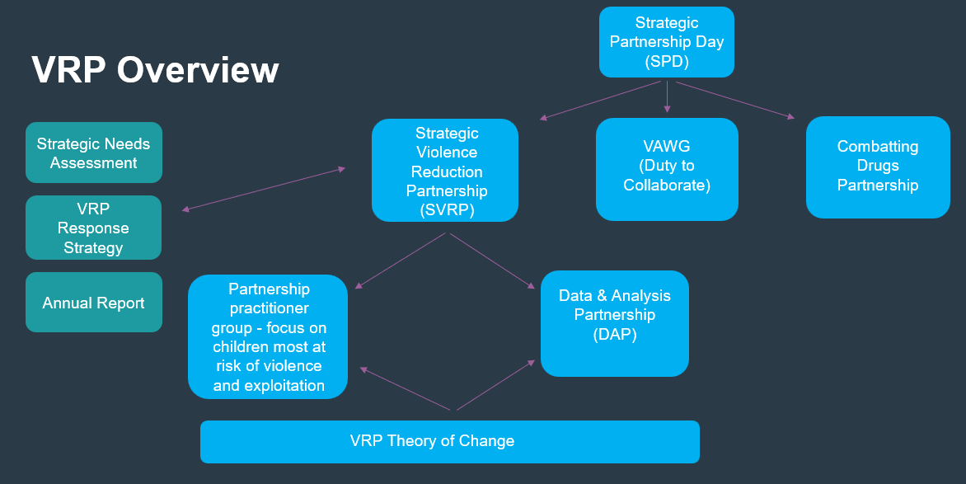
Figure 1

vision and mission
Our vision is for Hampshire, Isle of Wight, Portsmouth and Southampton to be a place where people can live their lives free from violence and the fear of violence.
Our mission is to prevent violence by building a collaborative, courageous and sustainable Partnership which will drive the change required to successfully address the causes and consequences of violence.

aims and activities linked to the theory of change (toc)
The SVRP will oversee the delivery of the VRP Response Strategy, offering leadership and strategic coordination of the local response to serious violence, which is captured within the VRP Theory of Change (ToC).
The following activities will be delivered by the SVRP, in alignment with the ToC.
- Coordinate Strategic collaboration with appropriate membership across the VRP, aligning to agreed Terms of References
- Promote delivery of lasting systems change, Core Membership accountability and challenging barriers to effective multi-agency working
- Active presence and voice at strategic forums across geographical areas to influence a multi-agency systems response
In addition, the SVRP will:
- Agree the VRP definition of Serious Violence

- Carry out the functions of the ‘Core Group’
- Oversee the Serious Violence Reduction Programme Grant (SVRPG) Delivery Plan
These activities will produce the following outputs:
- VRP Response Strategy
- 2026-2027 VRP Annual Report

MEMBER responsibilities for statutory services
Under the Serious Violence Duty, the following Specified Authorities are required to collaborate and plan to prevent and reduce serious violence:
- Police
- Justice (Probation Services and Youth Justice Service)
- Fire and Rescue Service
- Health (Integrated Care Boards)
- Local Authorities (District and County Councils)
The following Relevant Authorities are also expected to collaborate and plan to prevent and reduce serious violence:
- Prison Service
- Education
The Home Office has published guidance on ‘Partnership Engagement’. The responsibility from each Senior Responsible Officer (SRO), for all Specified Authorities, is to represent their organisation by ensuring the following is achieved:
- Understand the requirements of the Serious Violence Duty and actively seek opportunities to collaborate and improve the HIPS wide response, providing evidence at the SVRP
- Be a key decision maker at the SVRP
- Be responsible for completing the Quarterly highlight report and raising key updates at the SVRP, for partner awareness.
- Provide links to key partnership boards and will champion a Public Health, Trauma Informed Approach to serious violence in their organisation.
- Advocate for information and data sharing to take a ‘problem solving’ approach to tackling Serious Violence.
- Challenge each other to focus on solutions and interventions where there is an evidence base to show ‘what works’.
- Be open to and provide support to other Partners, sharing best practice.
- Take responsibility for ensuring the organisation they represent meets the requirements of the Police, Crime, Sentencing and Courts (PCSC) Act 2022.
- Ensure responsibility and accountability for:
- Oversight and strategic direction of the VRU
- Oversight of the SVRP Grant expenditure, including strategic implementation of the Young Futures Prevention Panels

MEMBER responsibilities for VCSE services
Role of the VCSE Sector:
- Bring the voice of the VCSE Sector and to provide a voice and perspective of the community
- VCSE representatives have been nominated by their respective Local Authorities and will work in collaboration with the wider partnership at the SVRP

reporting relationships
The VRU will submit ‘Quarterly Returns’ on Grant spend to the Home Office, in line with the Grant Agreement.
The Chairs of each sub-group under the SVRP will provide updates from these working groups.

meeting frequency and format
Meetings will be held quarterly.

administration
Actions and attendees will be recorded and published by the VRU to monitor progress against the strategic objectives.

As stated within the Home Office Serious Violence Duty (SVD) Statutory Guidance, December 2022.
Senior Responsible Officer (SRO) for the Serious Violence Duty
The Strategic Needs Assessment (SNA) allows us to understand data through analysis around which communities are impacted by serious violence and what we know about the root causes of violence.
The World Health Organisation (WHO) provided a 4-step process for implementing a Public Health Approach, which the Home Office has promoted as a methodology to tackle serious violence: - Surveillance - Identify Risk and Protective Factors - Develop and Evaluate Interventions - Implementation
Trauma Informed Approach focuses on ‘what has happened to this person, rather than ‘what is wrong with this person’.
Existing VRP sub-groups across HIPS are: - Practitioner Partnership Group - focus on children most at risk of violence and exploitation - Data and Analysis Partnership (DAP)
The ToC is a high-level representation of how the VRP’s resources and activities lead to the desired short, medium and long term changes, which will reduce serious violence and risk.
Voluntary, Community and Social Enterprise – VCSE

