

Information for New Groups

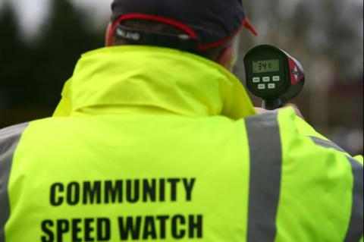

What is Community Speedwatch?

• Community SpeedWatch is a locally driven initiative, supported by Hampshire and Isle of Wight Constabulary where active members of the community monitor speeds of vehicles at specific locations using speed indication devices.
• The initiative allows the community to address the issue of speeding by becoming actively involved in road safety and working in partnership.
• Trained volunteers record the details of speeding vehicles. The registered keepers would then be informed by letter that they have exceeded the speed limit threshold.
• SpeedWatch is not enforcement, it is education. However it is important to know that SpeedWatch now forms part of our response to Speeding issues and forms the first Tier in our response to dealing with this problem

Joining/setting up a Speedwatch Scheme
• The minimum age for volunteering is 18.
• The scheme requires a lead volunteer who will act as the team coordinator. The Coordinator is responsible for the team’s activities and will collate the data following each session.
• All volunteers must complete an application form and submit this to the Citizens in Policing Team
Community SpeedWatch Application Form
• Once we have received your application form you will be invited to attend an online Community Speedwatch training session at the end of which volunteers will be required to sign a Service Level Agreement.

Expectations.
• At least three Volunteers are required at the side of Road with Speed Indication equipment
• Sites are predetermined and assessed by Police for safety considerations as well as ensuring they are not conflicting with current enforcement work
• Volunteers who identify a Speeding vehicle will manually record the time, speed, registration, make, model and colour of a vehicle.
• A Warning letter will be sent to the registered keeper on the 1st occasion that a vehicle is recorded.
• A 2nd warning letter will be sent to the registered keeper should they be recorded for a second time.
If a vehicle is recorded for a 3rd time, the registered keeper will receive a home visit and advice from an Officer.

Equipment
• The type of equipment authorised for use for Community Speed Watch in Hampshire and the Isle of Wight is a SID (Speed Indication Device).
• Hampshire and Isle of Wight Constabulary do not provide the equipment. It is the responsibility of the Speed Watch team/Council to obtain quotes.
• Hampshire and Isle of Wight Constabulary will need to authorise the product before the team/Council purchase it.
• The funding provider will be wholly responsible for the equipment including its storage, up-keep, servicing and any new batteries or maintenance that is required. You may wish to consider further funding to cover this and insurance for your Speed Watch equipment.
• Hampshire and Isle of Wight Constabulary cover the costs of training the volunteers and the use of the Speed Watch database including the licence for this. We also cover the paper and letter postage costs.
• Hampshire and Isle of Wight Constabulary do not ‘recommend’ any companies, however, you can obtain quotes from the list of companies below: –
Bushnell Speed gun
– www.radarspeedsign.com
– www.traffictechnology.co.uk
– www.morelock.co.uk/speed-signs
– www.smart-group.co.uk
– www.twmtraffic.com
– https://www.uniparservices.com/item/3/uniparservices/Sentinel.html
– http://www.elancity.co.uk/
for the ‘Evolis’ Radar speed signs (lamp posts mounted SIDs, extra permissions required).
• If you are purchasing equipment which will be fixed to a lamppost, please note further permissions and possibly costs are required for this.
• The team of SpeedWatch volunteers will be responsible for storing the equipment and transporting it to and from each roadside session.
• Some teams have approached local businesses for fundraising and have been able to obtain an amount towards the purchase of more costly high-vis jackets/coats. The business logo was agreed to be added to the jacket.
• Clip boards and pens will also need to be purchased and some teams have bought camping chairs. • High visibility tabards/vests or jackets must be purchased and worn by each member of the team at a roadside. These can be purchased online or in local shops, however the vests must comply to ‘BS EN 471’ which is the European standard for high visibility clothing.

Choosing a CSW Location.
• Each road chosen to conduct monitoring must be approved by a Police representative. This will be done by the Traffic Management unit with a local risk assessment following this.
• Each site is risk assessed by a local PCSO or PC to ensure it is safe to carry out CSW activity. This would include ensuring the road;
– Is a 20, 30 or 40MPH road.
– Has a minimum distance of 100m with unobstructed view (Turns / bumps / hills in the road, Parked Cars etc)
– Has a minimum distance of 150m from any change in speed limit.
– Avoids school areas / hatchings.
– Has enough space for the volunteers and kit to stand safely, without obstructing the walkway/area for pedestrians/Wheelchairs and Pushchairs.
– Including a consideration on where the volunteers will park.
• At the beginning of each session the team leader on the day will carry out a risk assessment to ensure it is safe to operate

If you have any further questions then please ask Speedwatch@hampshire.police.uk

