Violence Reduction Partnership
Halloween Anti-Social Behaviour Campaign
‘Be a Halloween Hero’
Communications and Engagement Pack

In this pack:
- What is the Violence Reduction Unit?
- What is the Violence Reduction Partnership?
- Campaign Overview
- Campaign Objectives
- Key Messages
- Campaign Digital and Social Media Resources
- Campaign Engagement Resources

What is the Violence Reduction Unit?
Hampshire and Isle of Wight VRU is a small team who work with partners to tackle the root causes of violence. The VRU supports the Violence Reduction Partnership (VRP) made up of 25 different public sector bodies across the Hampshire, Isle of Wight, Portsmouth & Southampton (HIPS) area who come together to make our communities safer.

What is the Violence Reduction Partnership?
The VRP is a partnership of authorities across Hampshire, IOW, Portsmouth and Southampton, who work together to tackle and prevent serious violence. They are police, health, justice fire, local authorities, education, prisons and the voluntary and charity sector.
The Serious Violence Duty was introduced under the Police, Crime, Sentencing and Courts Act 2022 and requires specified and relevant authorities to work together to prevent and reduce serious violence. The Serious Violence Duty requires partnerships to take a multi-agency, public health approach to understand the causes and impact of serious violence develop a strategic response, which focuses on prevention and early intervention, and monitor the impact of this response.
The Violence Reduction Partnership has a vision for Hampshire, the Isle of Wight, Portsmouth and Southampton to be a place where people can live their lives free from violence and the fear of violence.

Campaign Overview:
The "Be a Halloween Hero" campaign is all about making Halloween a time of fun, kindness, and community spirit. By focusing on positive choices, we aim to encourage young people to be leaders in their communities by showing respect, kindness, and responsibility. The message is simple: Halloween is for fun, not for fear!
Through engaging content, social challenges, and incentives, this campaign will inspire young people to take the lead in making Halloween a positive experience for everyone.

Campaign Objectives:
By creating fun and engaging online quizzes and social media content showing the benefits of making positive choices during Halloween. This content can be shared on social media, in schools, and through community organisations.

Key Messages:
- " Be Kind, Be Cool, Be a Halloween Hero:
  - Halloween is about having fun, dressing up, and enjoying spooky adventures—but not at someone else’s expense. Be a Halloween Hero by showing kindness and respect to others, from your neighbours to your friends.
- Positive Choices = Big Fun:
  - Positive choices like sharing sweets, respecting others' property, and helping out younger kids will earn you superhero status in your community! Kindness and respect make the night better for everyone.
- No Tricks, Just Treats:
  - Playing pranks and getting involved in ASB may seem fun in the moment, but the real fun comes from making memories, not causing problems. Choose treats over tricks and be a positive influence!
- Keep Your Community Spooky, Not Scary:
  - Help your community feel safe. Keep the fun spooky, not scary, by avoiding behaviour that might frighten or upset others, like vandalism or excessive noise. Together, we can keep Halloween a night of good times!
Campaign Resources
Please feel free to use these resources in the best way for you. We have created some suggested content you may wish to use. You can download all the resources from our Google Drive.
Please adapt to suit your audience or platform. We have included a list of useful website below, you may wish to consider their content and add to your posts. If there is anything else you think would help share the conversation wider please get in Touch with Sallie the VRU Comms and Engagement Officer on jackson.sweeting@hampshire.police.uk

Campaign Digital and Social Media Resources
Image | Link | Text
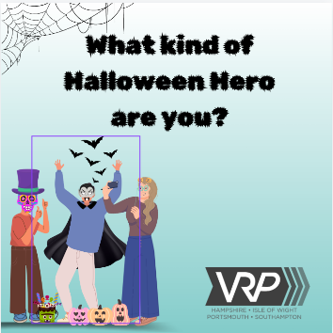  Image 1  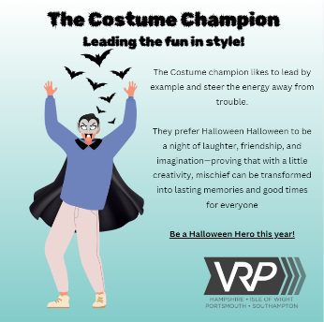  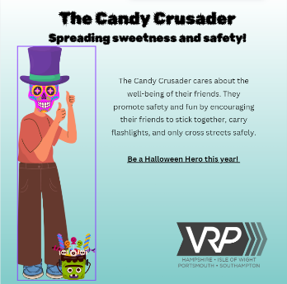  Image 2  Image 3  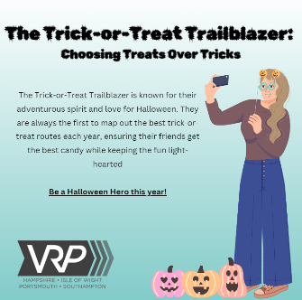  Image 4 | Image 1  Image 2  Image 3  Image 4 | 🎃👻 Be Kind, Be Cool, Be a Halloween Hero! 👻🎃  Halloween is all about fun, costumes, and spooky adventures—but remember, it's not cool to ruin someone else’s night!  ✨ Show kindness and respect to your neighbours, friends, and fellow trick-or-treaters. Be the hero of Halloween by keeping the spirit fun for everyone! 🙌  Swipe ➡️ to see which hero you are: 🍬 The Candy Crusader – spreading sweetness and safety!  👗 The Costume Champion – leading the fun in style!  🎒 The Trick-or-Treat Trailblazer – choosing treats over tricks!  Let’s make this the sweetest Halloween yet! 🍬🎉  #HalloweenHeros #BeKind #SpookySeason #HalloweenFun #NoTricksJustTreats #CandyCrusader #CostumeChampion #Trailblazer #SwipeToFindOut
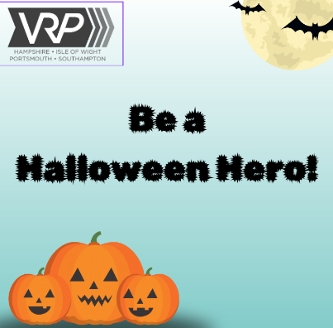 | Image | 🌟✨ Positive Choices = Big Fun! ✨🌟  Want to earn superhero status in your community this Halloween?  🦸‍♂️ Make positive choices like sharing your sweets, respecting others' property, and lending a helping hand to younger trick-or-treaters! 🍬🤝  Remember, kindness and respect make the night better for everyone. Let’s create a Halloween filled with fun, friendship, and fantastic memories! 🎃💖  #HalloweenHeroes #PositiveChoices #SpreadKindness #BigFun #CommunitySpirit #TrickOrTreat
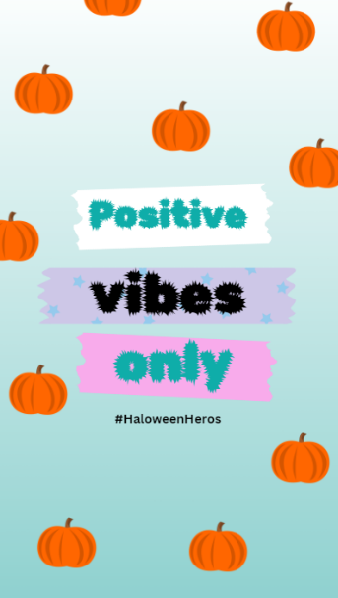 | Animation | 🌟✨ Positive Vibes Only! ✨🌟  This Halloween, let’s aim for superhero status in our community!  🦸‍♀💫 Make positive choices by sharing sweets, respecting others' property, and helping younger kids on their trick-or-treat adventures! 🍬👶  Remember, kindness and respect make the night better for everyone. Let’s create a Halloween full of fun, laughter, and memorable moments! 🎃💖  #HalloweenHeroes #PositiveChoices #SpreadKindness #BigFun #CommunitySpirit #TrickOrTreat
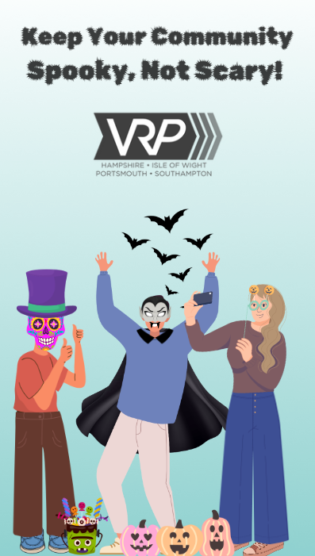 | Animation | 👻🎃 Keep Your Community Spooky, Not Scary! 🎃👻  This Halloween, let’s help our community feel safe and festive! ✨ Keep the fun spooky, not scary, by avoiding behaviours that might frighten or upset others—like vandalism or excessive noise.  Together, we can ensure Halloween remains a night of good times for everyone! Let’s celebrate with kindness and respect! 🙌💖  #SpookyNotScary #HalloweenFun #CommunitySpirit #SafeHalloween #GoodTimes

Campaign Engagement Resources
If you work with children and young people and are looking for a fun engaging activity that also shares positive messages around the right things to do this Halloween then dive into this fun personality quiz to discover your Halloween Hero persona! Are you "The Candy Crusader," "The Costume Champion," or "The Trick-or-Treat Trailblazer"? Each persona embodies positive actions that make Halloween enjoyable and safe for everyone!
Download the quiz here!
If you are worried about talking to children and young people about anti-social behaviour and don’t really know where to start we have produced an honest conversation tool to help you prepare for those trickier conversations.

Serious Violence and Knife Crime Participation Pack
Are you seeking more engaging activities for your group? We have developed a Serious Violence and Knife Crime Participation Pack, featuring three interactive activities, each designed to be completed in just 15 minutes.
This pack serves as an empowering tool for young people, helping them learn more about the realities of serious violence and knife crime. Through these engaging activities, participants will explore critical topics, gain valuable insights, and foster meaningful discussions. By providing a safe space to share their thoughts and experiences, the Participation Pack encourages young individuals to reflect on the impact of violence in their communities.
Download Participation Pack Here!

