1. **Purpose**

**Title of the Board:** Joint Audit Committee **Item**

**Meeting date:** 19 November 2024

**Subject:** Statement of Accounts 2022/23

**Author of report:** Richard Croucher, Chief Finance Officer

* 1. The backstop date for 2022/23 statement of accounts has been set at 13 December 2024. Therefore, the final 2022/23 accounts will need to be published at that date with a disclaimer opinion from external audit.
  2. The draft 2022/23 statement of accounts were published online at the end of May 2023 and presented to the Joint Audit Committee in September 2023. While there will not be a full audit of the accounts, the Value for Money statement for 2022/23 has been produced by the external auditors and some testing of 2022/23 figures has been undertaken in order to assist with assessing opening balances for the ongoing 2023/24 external audit.
  3. During this time, some amendments have been agreed to be made to the 2022/23 accounts. There are no changes to any of the key financial statements and there are no material changes, but for transparency, all changes that have been made have been listed below and shown in the attached appendices The changes made are summarised below:

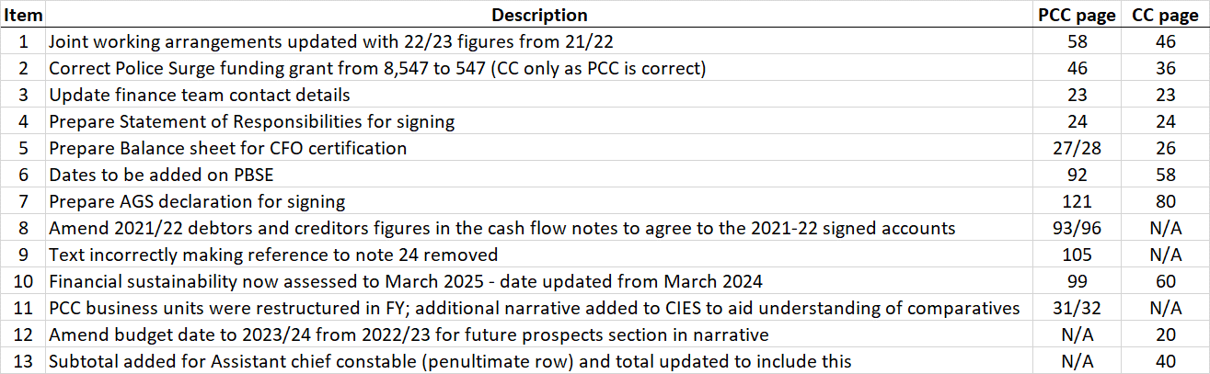

* 1. The revised final 2022/23 accounts for both the OPCC and Constabulary are also attached, but without an audit opinion or disclaimer at this stage.

1. **Recommendation**
   1. The Committee is invited to raise any questions on the amendments made and offer feedback for the PCC and Chief Constable to consider before the final accounts are required to be signed and published.

**Appendix 1**

**Adjustments made by Accounting Team**



**EY suggested adjustments**

