Violence Reduction Partnership (VRP)

Strategic Violence Reduction Partnership (SVRP) Board

Terms of Reference (ToR)

March 2024

distribution list and SVRP membership
Agency | Specified or Relevant Authority | Name & Role / Partner
Office of Police and Crime Commissioner (OPCC) | N/A | PCC (Chair)  Chief of Staff
Violence  Reduction  Unit (VRU) | N/A | VRU Director  VRU Managers  Hampshire and Isle of Wight Together (HIOWT) Engagement Lead  VRU Programmes and Projects Officer
Police | Specified Authority | Assistant Chief Constable  Strategic Lead for Serious Violence  Tactical Lead, Violence Crime Taskforce
Hampshire and Isle of Wight Fire & Rescue Service (HIWFRS) | Specified Authority | Assistant Director Operations
Youth Justice Service (YJS) | Specified Authority | Southampton YJ Manager  Portsmouth Head of Service and YJ Manager  Hampshire and Isle of Wight Head of Service  IOW YJ Manager
Health – Integrated Care Boards | Specified Authority | Representation from Hampshire and Isle of Wight  NHS England Public Health Lead  Representation from Hampshire and Isle of Wight Public Health
Local Authorities | Specified Authority | Representation from Hampshire County Council  Representation from Portsmouth City Council  Representation from Southampton City Council  Representation from Fareham Borough Council  Representation from Gosport Borough Council  Representation from Winchester City Council  Representation from New Forest District Council  Representation from Rushmoor Borough Council  Representation from Hart District Council  Representation from Test Valley Borough Council  Representation from Havant Borough Council  Representation from Eastleigh Borough Council  Representation from East Hampshire District Council  Representation from Basingstoke and Dean Borough Council  Representation from Isle of Wight Council
Probation | Specified Authority | Representation from Probation
Education | Relevant Authority | Representation by local authorities
Prison Service | Relevant Authority | Representation from HMP Winchester
Voluntary Sector | N/A | Representation from Action Hampshire

Contents
Distribution list and SVRP Membership 2
Introduction 4
Vision and Mission 5
Aims and Activities Linked to the Theory of Change (toc) 6
Crest Advisory Recommendations 7
Outcomes Based Performance Framework 7
Board Member Responsibilities 8
Reporting Relationships 9
Meeting Frequency and Format 9
Administration 9

Cover Photo: Logo

introduction
The Strategic Violence Reduction Partnership (SVRP) has been established to develop and deliver a Strategy to address the root causes of serious violence in our communities, based on the findings obtained within the Strategic Needs Assessment (SNA) . This is in accordance with the Home Office Serious Violence Duty (SVD) Statutory Guidance.
The SVD under the Police, Crime, Sentencing and Courts Act 2022 (PCSC Act) requires Specified and Relevant Authorities to come together to share data to understand drivers of serious violence and develop clear plans to combat this, with a focus on public space violence.
Within Hampshire, Isle of Wight, Portsmouth and Southampton (HIPS), the Violence Reduction Unit (VRU) are responsible for leading on this approach and their core function is to offer leadership and strategic coordination of the local response to serious violence by working collaboratively with all Partners within the Violence Reduction Partnership (VRP), promoting a Public Health and Trauma Informed Approach.
The VRP recognises that tackling serious violence is not a law enforcement issue alone and requires a collaborative Partnership approach.
The Police and Crime Commissioner (PCC) for Hampshire and Isle of Wight will chair the SVRP as part of the ‘convening’ role for PCC’s to bring together the VRP through the SVRP and working groups, under the SVD. Refer to figure 1.

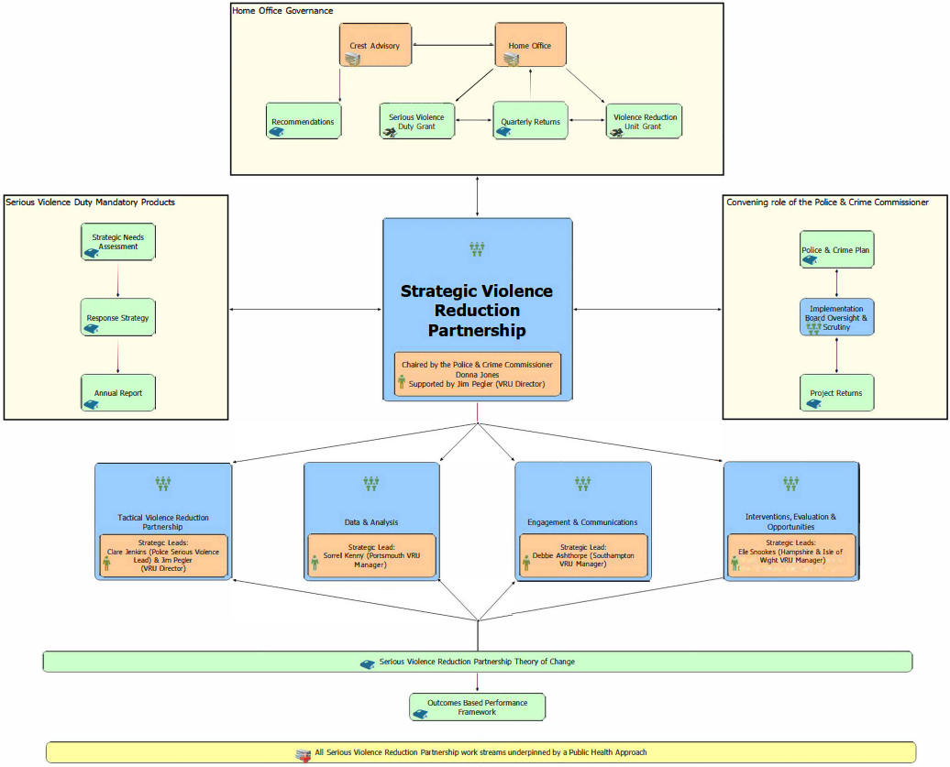
Figure 1

vision and mission
Our vision is for Hampshire, Isle of Wight, Portsmouth and Southampton to be a place where people can live their lives free from violence and the fear of violence.
Our mission is to prevent violence by building a collaborative, courageous and sustainable Partnership which will drive the change required to successfully address the causes and consequences of violence.

aims and activities linked to the theory of change (toc)
The SVRP will oversee the delivery of the VRP Response Strategy, offering leadership and strategic coordination of the local response to serious violence, which is captured within the VRP Theory of Change (ToC).
The following activities will be delivered by the SVRP, in alignment with the ToC.
- Review governance arrangements to ensure the VRP is streamlined, with appropriate representation and positive engagement from all the specified and relevant authorities, as well as other stakeholders as required (1.a)
- Set clear expectations in terms of the contribution of all specified authorities to the Serious Violence Duty. To ensure consistency between activities in each local authority area, a central concordat will be sent to practitioners in each area, clearly defining the roles, responsibilities and remits under the Serious Violence Duty for each partner authority (1.b)
- Co-produce the responses to serious violence, including the Response Strategy, with a range of partners, including the voluntary community sector (VCSE) and local communities, especially children and young people most affected by serious violence. With a focus on, communicating and embedding an understanding of the need for a Public Health and Trauma Informed Approach in all member agencies in support of the Trauma Informed Execute Board (1.c)
- Create a plan for sustainability with the aim of identifying opportunities for long-term system change and to create an environment in which the VRP can exist without dependency on central funding (1.d)
In addition, the SVRP will:
- Carry out the functions of the ‘VRU Core Group’ (as defined in the VRU Grant Agreement) and oversee the VRU Delivery Plan.
- Oversee the SVD Grant Delivery Plan.
- Explore opportunities for co-location of teams and secondments between organisations.
The scope of the SVRP is defined by the VRP definition of serious violence.
The SVRP will also seek to align the VRP Response Strategy to complement existing Community Safety Partnerships (CSP) and broader strategies.

crest advisory recommendations
The Home Office commissioned Crest Advisory to assess the VRP’s readiness to meet the SVD and made necessary recommendations to the Partnership to reach maturity.
The following recommendations are recorded in the Crest Advisory Recommendations Tracker, which will be considered and delivered by the SVRP:
- Set expectations with all Specified Authorities on what they are expected to contribute to the Duty (4.1).
- Disseminate a centralised message to practitioners in each area, clearly defining the roles, responsibilities and remits under the Duty for each partner authority (4.2).
Once a recommendation has been achieved, the Crest Advisory Recommendations Tracker will be updated and the SVRP ToR will also be revised to reflect this.

outcomes based performance framework
The VRU has developed an Outcomes Based Performance Framework on behalf of the VRP to track performance progress for each strategic area, under the SVRP, to reduce serious violence.
The impact of activity from the SVRP should be measured by the following elements of the Performance Framework, which will be monitored and reported on quarterly:

- Serious Violence is reduced across Hampshire and Isle of Wight and will be measured by:
- ICB data: number of hospital admissions for assaults with a knife or sharp object - Home Office measure (1.1.1.a)
- Constabulary: number of police recorded knife-enabled serious violence incidents - Home Office measure (1.1.1.b)
- Constabulary: number of police recorded non-domestic homicides - Home Office measure (1.1.1.c)
- Constabulary: number of serious violence offences using the VRP serious violence definition (1.1.1.d)
- Strengthened multiagency working. The success measure to achieve this will be:
- Specified and relevant authorities attending and engaging with partnership meetings, measured by data source:
- VRU: number of specified and relevant authorities attending Serious Violence Reduction Partnership meetings (2.1.1.a)
- Specified and relevant authorities understand their role in response to serious violence. The success measure to achieve this will be:
- Specified and relevant authorities have a good understanding of their role in key aspects of the response to serious violence, measured by data source:
- VRU: percentage of ratings of 'good understanding' and 'full understanding' in ‘VRP - Specified and Relevant Authorities' Understanding of SV Response Role’ survey (2.2.1.a)

BOARD MEMBER responsibilities
Under the Serious Violence Duty, the following Specified Authorities are required to collaborate and plan to prevent and reduce serious violence:
- Police
- Justice (Probation Services and Youth Justice Service)
- Fire and Rescue Service
- Health (Integrated Care Boards)
- Local Authorities (District and County Councils)
The following Relevant Authorities are also expected to collaborate and plan to prevent and reduce serious violence:
- Prison Service
- Education
The responsibility from each member of this group is to represent their organisation by ensuring the following is achieved:
- Understand the requirements of the Serious Violence Duty and actively seek opportunities to collaborate and improve the HIPS wide response.
- Have active and meaningful roles in the partnership, including identifying the right individuals to participate in the governance arrangements and lead on serious violence, as well as seeking senior leadership buy-in and support from within their own organisations.
- Provide links to key partnership boards and will champion a Public Health, Trauma Informed Approach to serious violence in their organisation.
- Advocate for information and data sharing to take a ‘problem solving’ approach to tackling serious violence.
- Challenge each other to focus on solutions and interventions where there is an evidence base to show ‘what works’.
- Be open to and provide support to other Partners, sharing best practice.
- Understand the requirements of the SVD and collaborate to improve the HIPS wide response.
- Board members will take responsibility for ensuring that the organisation they represent meets the requirements of the Police, Crime, Sentencing and Courts (PCSC) Act 2022.
- Ensure responsibility and accountability for:
- Oversight and strategic direction of the VRU
- Oversight of the VRU Grant expenditure
- Oversight of the SVD Grant expenditure
The SVRP replaces the VRU ‘Core Group’ and has expanded the membership to include Specified Authorities under the PCSC Act 2022.
It is important to note that the Core Group is a requirement of the VRU Grant Agreement, therefore any member of the SVRP is a member of the Core Group and will have a partnership voice on VRU Grant decisions (regardless of not being signatories of the three year VRU Grant Agreement).

reporting relationships
The VRU will provide ‘returns’ on Grant spend to the Home Office, in line with the Grant agreement. These returns will be submitted by the VRU Director and shared with the SVRP.
The Chairs of each sub-group under the SVRP will provide updates from these working groups.
The Terms of Reference, membership and actions of the SVRP will be shared with the Home Office.

meeting frequency and format
Meetings will be held quarterly.

administration
Actions and attendees will be recorded and published by the VRU to monitor progress against the strategic objectives.

As stated within the Home Office Serious Violence Duty (SVD) Statutory Guidance, December 2022.
The Strategic Needs Assessment (SNA) allows us to understand data through analysis around which communities are impacted by serious violence and what we know about the root causes of violence.
The World Health Organisation (WHO) provided a 4-step process for implementing a Public Health Approach, which the Home Office has promoted as a methodology to tackle serious violence: - Surveillance - Identify Risk and Protective Factors - Develop and Evaluate Interventions - Implementation
Trauma Informed Approach focuses on ‘what has happened to this person, rather than ‘what is wrong with this person’.
Existing VRP sub-groups across HIPS are: - Tactical Violence Reduction Partnership (TVRP) - Data and Analysis Working Group (DAWG) - Engagement Working Group - Communications (Comms) Working Group - Interventions, Evaluations and Opportunities (IEO) Working Group
The ToC is a high level representation of how the VRP’s resources and activities lead to the desired short, medium and long term changes, which will reduce serious violence and risk.
Number per activity aligns to that shown in the VRP Theory of Change.
With the aim of preventing and reducing the impact of adverse childhood experiences a Trauma Informed Executive Board has been established to embed trauma–informed and restorative practice and encourage agencies to work together, alongside vulnerable people, families and communities.
Hampshire, Isle of Wight, Portsmouth, Southampton (HIPS) Exploitation, Public Health Approach, Trauma Informed Approach, Youth Justice and Violence Against Women and Girls (VAWG).
Recommendations from Crest Advisory (Crime and Justice Specialists) were published in the ‘Joint Readiness Assessment for Hampshire & Isle of Wight’ (published May 2023).
Number per recommendation aligns to that provided by Crest Advisory.
Number per element aligns to that shown in the Outcomes Based Performance Framework.

