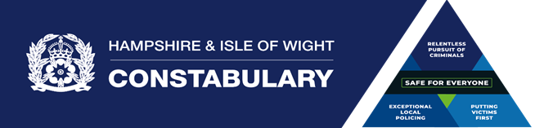
Support for Victims of Crime in your workplace

The National Crime Business Centre has developed a Framework for Employers that signpost’s sources of guidance and advice for how retail employers can help to prevent violence and abuse in retail settings and protect the wellbeing of their employees. Employers are encouraged to use this, in particular the post-incident support section, which is a guide to assist employers to support employees after they have been affected by violence or abuse in the workplace. This framework, can be accessed via the following link: NBCC_Preventing-violence-abuse-in-retail_FINAL.pdf
In addition, this local guidance compliments the national framework and provides signposting to local services that can support victims of crime in all types of business and retail settings within Hampshire & the Isle of Wight.
What Victim Care do
The Victim Care Hub is a service designed and commissioned by The Police & Crime Commissioner for Hampshire & the Isle of Wight. The Hub is a single point of contact for victims, witnesses and those affected by crime to receive support and information. The Victim Care Hub is a free and confidential service, available to anyone regardless of whether the crime has been reported to the police or how long ago it took place. Support is tailored to you, focusing on areas of support you want support with, these may include safety, information, connecting to other agencies or listening and validating your experiences. Support is available 24/7 365 days per year.
Click on the links below to access the websites.

