NATIONAL POLICING AND CRIME MEASURES
2022/23 Q2
Hampshire & Isle of Wight Constabulary
And
Office of the Police and Crime Commissioner for Hampshire and Isle of Wight

This document is a statement on Hampshire and Isle of Wight Constabulary’s contribution to the national policing and measures.
The key national policing priorities are:
- Reduce murder and other homicide
- Reduce serious violence
- Disrupt drugs supply and county lines
- Reduce neighbourhood crime
- Improve victim satisfaction with a focus on victims of domestic abuse
- Tackling cyber crime

The document will be updated quarterly and will include:
- A summary of relevant statistics – where relevant a comparison will be made against the baseline year 2018/19 and measures tracked for the latest 6 and 12 months
- Review of performance and the Constabulary’s contribution towards the priorities
- The planned action for the force to improve performance against the measures

Priority area: Reduce Murder and other homicide
Measures:
- Police recorded homicides
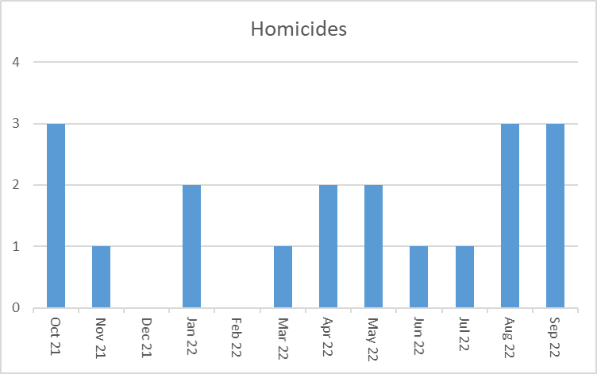
Force response to homicides:

Major Crime (MC) Department own all confirmed homicide cases within the Constabulary and maintain oversight for the accuracy of reported data, including: CRISMSEC7, crime data integrity and data system management (HOLMES/Niche). The force operate according to a surge model. This means there is a lean core-group of trained staff responsible for fulfilling mandatory MIRSAP roles; the wider force then supplements MC with additional staff to meet peaks in demand. Over the last 12 months a cadre of officers trained in the management of HOLMES/MIRSAP has been developed outside of the department to enhance resilience.

The force response to homicides is dependent on the dynamics of each particular case. Cat A and A+ offences are typically supported by a Gold group and PIP4 to ensure there is adequate organisational focus and operational space to meet the additional demand these cases pose. There is always an on-duty homicide-trained PIP3 Senior Investigating Officer (SIO) available to lead cases within the force as they emerge. This is covered via callout out-of-hours.

Major Crime and the Child Abuse Investigation Team (CAIT) are co-located in the Constabulary’s 3 bases (N, E and W). CAIT cover attendance at all child deaths 24/7. This rota is staffed by Detective Inspectors who have undertaken child death investigation training. If homicide (beyond reckless accidental death of a baby) is suspected, MC will assume ownership. CAIT take an active part in every Joint Action Response (JAR) meeting following child death and will chair these in the event of criminality being suspected. The JAR has an ongoing mission to realise the holistic situations around each child’s passing to avoid further harm to others who may still be in the environment initial harm occurred in. It also has a responsibility to initiate positive change to practice and procedure and share information in the interests of child safety.

Profile of offences (October 21 – Sept 22):

Knife, drugs and criminal groups

- 9 of the 19 recorded offences involve the use of a knife.
- 5 of those of offences involving a knife have been associated to drugs related issues.
- 3 of the 5 offences involving drugs and knives have been associated to criminal groups/associations with apparent planning and premeditation.

Domestic offences

- 5 of all offences recorded involve a domestic violence connection.
- Only 2 of those offences link to a traditional partner on partner relationship
- 2 involve neglect/mercy killings
- 1 was a brother on brother stabbing.

Learning and Review

Any case managed within the MC department is subject to a level of debrief proportionate to its scale, complexity or sensitivity. Learning is shared with the force’s Organisational Learning Team with appropriate tracking on potential improvements.

Serious Case Review Team

The Serious Case Review Team (SCRT) have responsibility for:

- Child Safeguarding Practice Reviews (CSPR)
- Safeguarding Adult Reviews (SAR)
- Domestic Homicide Reviews (DHR)
- Multi Agency Public Protection Arrangements Serious Case Reviews (MAPPA SCR)

SCRT are staffed by a number of experienced senior detectives, including some who maintain their PIP3 credentials. This provides important capacity for peer review on complex cases in exceptional circumstances as well as delivering their listed responsibilities. Their focus is to extrapolate learning opportunities realised through their review activity and support the force to deliver improvement by influencing changes to practice, policy and procedure.

Ongoing focus:
Hampshire Constabulary are committed to ensuring that the response to homicide delivers justice for victims and their families by:

- Growing resilience and maintaining a skilled homicide investigation workforce
- Placing victims and their families at the heart of every case
- Maintaining platforms for learning to improve service provision and maintain public safety
- Understanding Hampshire’s offending profile and using this information to inform our response to onward homicide prevention.

Priority Area: Reduce Serious Violence

Measures:
- Hospital admissions of u25s for assault with a sharp object (NHS data)
- Offences involving discharge of a firearm (police data)
A number of crime categories are considered to as contributors to serious violence:

Firearms:
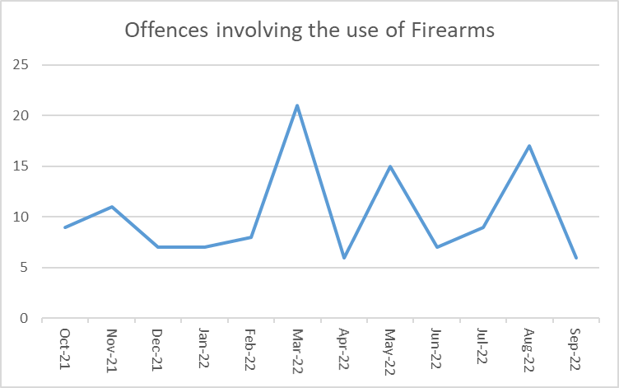

Knife Crime:
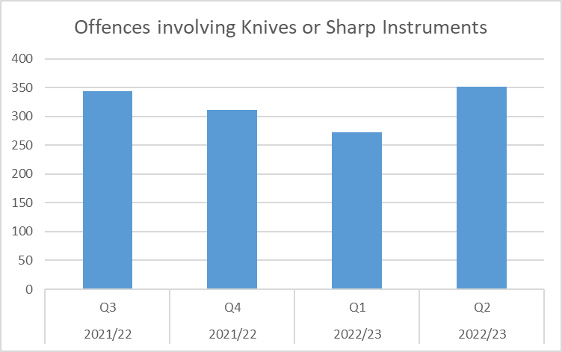

Serious Violence (Robbery and Violence with Injury as per the National Definition):

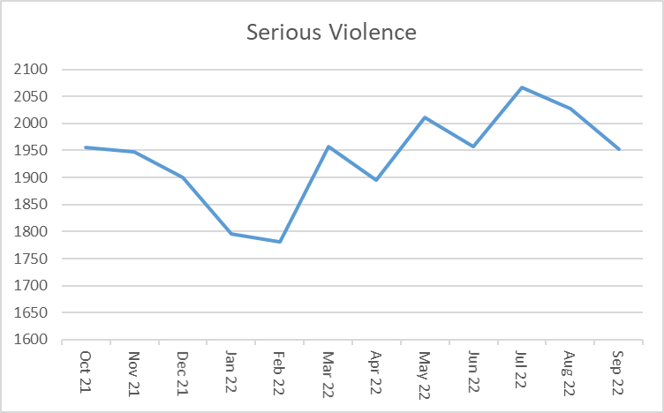

Force response to reducing serious violence:
We have now recruited 1 new Inspector, an additional Sergeant, 10 Constables and 2 Analysts to work across the force and alongside the Violence Reduction Unit to tackle violent crime hotspots and repeat perpetrators of serious violence. This is using GRIP funding and the team has been named the Violent Crime Taskforce (VCT). This is an investment, supported by the Home Office and PCC, of over £700k per year to add to the force’s pre-existing investment in the Neighbourhood Policing High Harm Teams. We have been continuing to target addition high visibility patrols across the force’s 18 designated violent crime ‘micro’ hotspots, which is resulting in violent crime reducing in those locations at a greater rate than the rest of the force. We are using this approach to enhance focus on the critical issues of Serious Violence and making it clear to the public and our partners that we see tackling this criminality as a critical priority for the force, alongside an improved OPCC led Violence Reduction Unit. The VCT core role remains one of problem solving, they ensure they service the requirement of the hot spot policing plan but have also received training in problem solving approaches to policing and are expected to apply these in terms of victims, offenders and locations in the areas they cover. The VCT is in turn overseen by a dedicated VRU (Violence Reduction Unit) Inspector who works alongside and is co-located with the VRU. The VRU has recently been refreshed and sits under the governance of the Police and Crime Commissioner (PCC), with a dedicated director and 4 geographically assigned managers. There is a VRU core group chaired by the PCC with membership from across the partnerships in Hampshire and the Isle of Wight.
The Force strategic lead – Supt Simon Tribe oversees a Tactical group – members include the VRU Inspector who also oversees Op Sceptre (knife crime) and Op Calibre (personal robbery), a Media and Comms representative for both internal and external messaging, a Neighbourhood policing representation and an
Investigations lead. The focus of the group is on problem solving and crime reduction via VRU/VCT and HHTs as well as focus on investigations in terms of volumes of outstanding suspects, management of repeat offenders and investigation outcome rates.

Ongoing focus:
Operation Sceptre – the National knife crime week of action was undertaken in November, this resulted in 48 arrests, 12 knives taken off streets located during stop and search and 213 knives recovered including 164 surrendered as part of amnesty. Neighbourhood policing teams joined partner agencies to hold community engagement events across the county including talks by ex-offenders sharing their lived experiences. Weapon sweeps were undertaken in parks and open spaces and were conducted with the support of local metal detection groups. Education workshops were given at secondary schools and licensing teams conducted test purchase operations for bladed items at shops in a number of towns across the force area.
This was then followed in December by Operation Calibre – the National Robbery week of action. This involved focus on preventative patrols in Southampton and Portsmouth city centres and resulted in a significant reduction compared to the previous week. Focus work was also undertaken between the VCT and Investigations team, resulting in outstanding suspects being detained and a significant reduction in the number of suspects still remaining outstanding for robbery offences (26 reduced down to 8, of whom 2 are currently in prison). The week was also accompanied by school robbery awareness training and sharing of resources from other forces in terms of messaging used to ensure young people are aware of how to look after themselves and their property.
Following on from Operation Calibre, the methodology used around outstanding suspect management is to be applied across other areas of Serious violence with a view to improve the timeliness of outcomes, as well as seeking to reduce offending by repeat offenders by maximising opportunities to detain them as soon as practicable.
The Serious Violence lead is ensuring that close links are maintained with areas of focus around Violence Against Women and Girls (VAWG) as well as Domestic Abuse. VCT officers are working with HHT officers and licensing teams around Night Time Economy areas which see serious violence and violence perpetrated against females. Work is underway to profile offender behaviour within the NTE and use behaviour pattern recognition processes to identify possible perpetrators.

Priority area: Disrupt drugs supply and county lines

Measures
- Drug-related homicides (police recorded data)
- Police referrals into drug treatment (Public Health England)
Force response to disrupt drugs supply and county lines:
The homicide problem profile for Hampshire is currently being written, but homicide did form part of the force strategic assessment in March 2022. It summarised that overall the number of homicides is low and, that once infant or child deaths are removed from the data, the headlines are DA and drug related although there are equal numbers of homicides that fall outside of these categories. The current force focus is to achieve a 20% reduction in homicide.

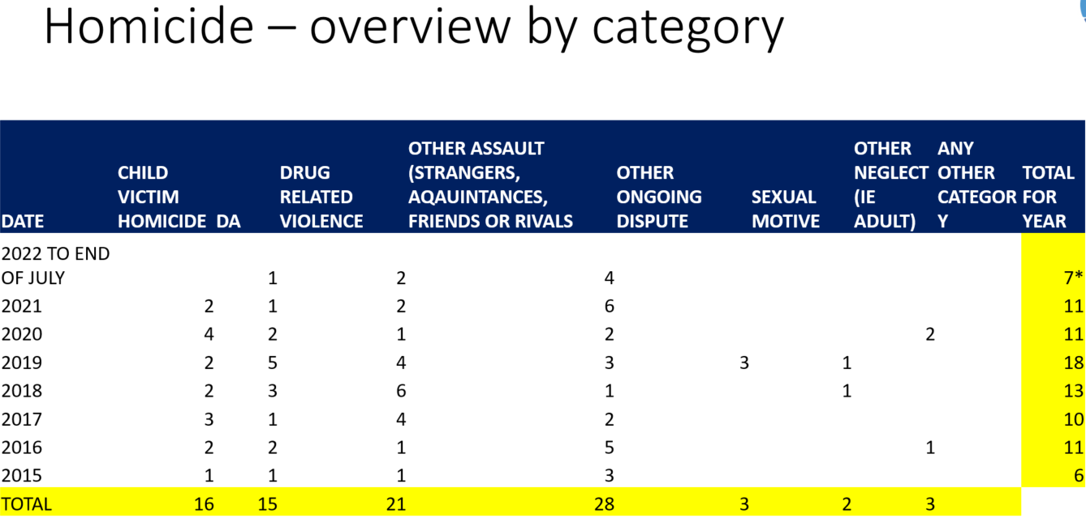

The force has implemented Drug Testing on Arrest at Basingstoke Custody centre. Mandatory and targeting testing has both achieved a high rate of identifying those offenders that has used heroin and/or cocaine. The scheme refers them into a treatment provider for assessment and intervention. The figures for the first quarter of delivery will be available in January 2023 but indications are a positive rate for ~50% of those tested.

The new combatting drugs partnerships have been launched in Hampshire, IOW, Southampton and Portsmouth and treatment services data will be available to those groups throughout 2023 and reported into the OPCC.

Ongoing focus:
Progression of cases involving possession of drugs with intent to supply in order to control offending and access criminal justice treatment pathways.
Refresh of County Lines delivery with focused delivery alongside Metropolitan police colleagues closing lines and safeguarding vulnerable person.
Expansion of DToA into other custody centres and refresh of commissioned services to improve immediate engagement whilst in custody. Future DToA opportunities being reviewed regarding ancillary orders and new treatment interventions connecting stimulant misuse and domestic abuse targeting homicide prevention.
Six months into the launch of the Serious Organised Crime Community Co-ordinator position they are delivering a review of lead responsible officer organised crime plans, with a focus on prevent, protect and prepare plans. The regional organised crime unit are recruiting a regional SOC CC providing an opportunity to create a problem solving network across SOC threats.
Jan 2023 launching Clear Hold Build Strategic oversight group within Intelligence and Tasking to build on learning from Op Hem and roll out across other organised crime threats and harms in communities through revised system of tasking and accountability.

Priority area: Reduce neighbourhood crime

Measures
- Residential burglary, robbery (personal), theft of and from a vehicle, theft from a person (source: Crime Survey of England and Wales)
- Currently there is no reportable measure within Crime Survey of England and Wales (CSEW).
- Combined measure of data on residential burglary, robbery (personal), vehicle crime and theft from the person offences:

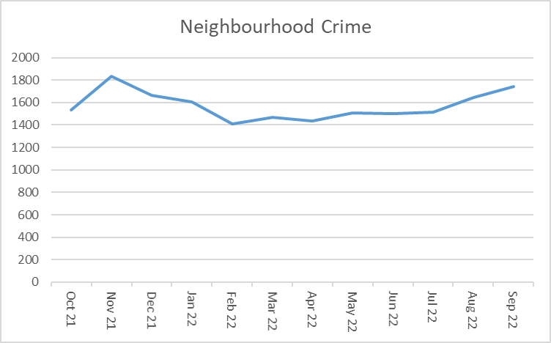

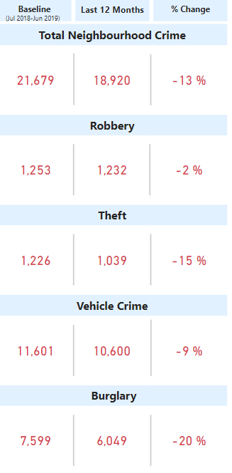
The crime categories (residential burglary, vehicle offences, theft from person and personal robbery have seen reduction in the latest 12 months compared to the baseline year). All these crime categories have experienced higher levels in 2022 compared to 2021 (COVID).
Dwelling burglary has experienced higher numbers for Q1 and Q2 of 2022 – the rates are lower than the baseline year but higher than similar forces.

Force response to reducing neighbourhood crime:

Neighbourhood crime is reviewed as part of district performance meetings and at Area Performance. At District level identification of series, repeat victim, offenders and location is undertaken and where applicable a district priority set. District priorities are run under SARA unless there is an immediate disruption element – ie known prolific offender. At Area performance investigation leads present data on commission rates and outcomes and update on Proactive activity by Operation Hawk (Burglary) or Proactive teams. Where necessary further analytical work may be requested to inform the policing response. There is close working between specialist investigation teams, neighbourhood policing and the High Harm Teams.
Vehicle crime is prioritised when there is a series or clear suspect.

All neighbourhood officers have now completed their SARA elearning to compliment elements within initial training and as a refresher for more experienced officers.

The force has a detailed Burglary improvement plan as a result of a Burglary Improvement Group, which brings together leads from key areas across the force to create a whole system approach to develop and deliver a 4P plan. Stakeholders within the group are held to account for activities conducted within the plan to deliver on creating a sustained and long-term improvement in our response to dwelling burglary.

Primary focus has been on our initial response to attend all dwelling burglaries. With the use of a burglary pack, to support the quality of the initial investigative response, Golden Hour Enquiries can help maximise the opportunity to identify a suspect in order that further action can be taken. Localised training has instigated this process within R&P with plans being progressed to extend this to P&N. This will be further supported by Frontline Training in early 2023.

Operation Hawk has seen an establishment uplift in numbers to enable them to actively undertake the pursue element of the plan and effectively manage the collective response required. Revised terms of reference will see them tackling the ‘burglar’ and not just the burglary and monthly meetings across the 3 districts will ensure that all invested parties (including ITD, IOM, SSD, R&A) are active participants to contribute to our overall investigative response to burglary, to charge more suspects and improve our solved rate.

Changes within Area Performance mean increased focus will now be placed on dwelling burglary where districts see a specific rise in commission and where applicable to address this through the use of district priorities. This increased district focus will ensure that daily searches and the use of local R&A and ITD will help to support the work of the Hawk Teams whilst utilising the P&N teams in both the prevent and protect space. R&A conducted at a local level will help P&N teams provide community reassurance with targeted hotspot patrols which will link into localised communication strategies to promote this work and encourage engagement effectively feeding into an improved intelligence picture. At force level a communications and media strategy has been approved with a specific timeline of campaigns set to address seasonal trends along with campaigns focused around periods of greater vulnerability.

The Force has recently changed its structure to Violence reduction. Working closely with the VRU Director at the OPCC there is a dedicated Violent Crime Task Force that are a taskable asset to address violence hotspots. A problem Profile has been produced which is refreshed to inform patrol , prevention and enforcement activity

Information is shared at partnership meetings with local wardens, housing associations and community safety partners

Ongoing focus:

Ongoing engagement with communities including crime prevention campaigns linked to patrol activity. At present there is an increase in Burglary (inc Sheds and Garages) . In the districts that are seeing the increases this is a district priority. Attendance at Burglaries is prioritised and monitored at Force Performance meetings and the priority is to maximise investigative opportunities at initial attendance, using specialist teams such as crime scene investigators and ensuring information and intelligence is shared with local policing teams. Robbery, particularly youth related is reviewed at Daily meetings and youth suspects are prioritised for arrest or voluntary attendance.
Focus is on the timeliness of investigations, reducing youth first time entrants to the Criminal justice system and ensuring the right outcomes for victims. Deferred prosecution is now established across the two counties .

Local policing Neighbourhood Teams scan daily activity that is reported to police in their neighbourhoods. In addition they talk to communities both face to face and on social media to establish local priorities. They talk to local councillors and other professionals who work locally to gain a shared understanding of issues to enable best use of resourcing.

A Neighbourhood policing board has been established, meeting for the first time in January to ensure consistent delivery of the Neighbourhood policing guidelines in every district. A peer review is being conducted in early January by Sussex and a benchmarking exercise has been completed in readiness for that review.

We are progressing best practice from other forces ‘Humber Beat’ in which PCSO’s will target survey activity in seldom heard areas and Liverpools ‘walk and talk’ in relation to VAWG in which we invite women to patrol and talk about feelings of safety and issues they may be experiencing. This has already started in some districts with valuable feedback leading to target hardening in hotspot areas.

Priority area: Improve satisfaction among victims, with a particular focus on victims of domestic abuse

Measures
- Satisfaction with the police among victims of domestic abuse (CSEW)
- Victim satisfaction with the police (CSEW)
Currently there is no reportable measure within CSEW.

A survey of domestic abuse victims commissioned through Hampshire and Isle of Wight Constabulary shows:
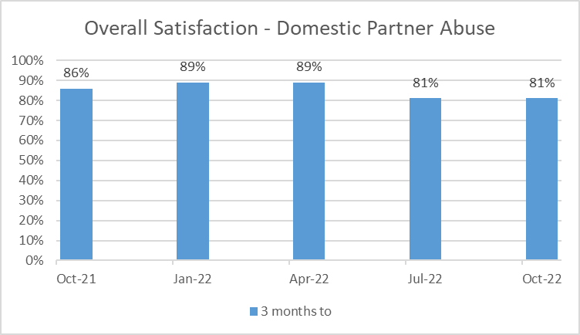

An online survey of victims of crime carried out by Hampshire and Isle of Wight Constabulary shows:

In Q1 (Apr-Jun) 2022, the overall satisfaction rate was 55%.
In Q2 (Jul-Sep) 2022, the overall satisfaction levels was 46%. In the same period the previous year (Jul-Sep 2021), the overall satisfaction was 51%.
Force response to improving victim satisfaction:

Force Satisfaction is one of the four Force Performance Goals and is reported on monthly.

The force has two distinct satisfaction surveys where we seek feedback on how we can improve as well as positive aspects of our service.

The Domestic Abuse survey is a telephone survey and shows consistently good overall satisfaction levels of over 80%. This is supported by significant investment in training and scrutiny work (such as reviewing Body Worn Video of attending officers) which sits under the force Domestic Abuse Strategy owned by a Chief Superintendent.

For other crimes outside of Domestic Abuse the force uses an online survey. Links are sent out by email or text 6 weeks after the report of a crime. This survey normally averages around 50% satisfaction. Whilst this survey cannot be directly compared to the telephone survey the Constabulary recognises the need to focus on improvement in these overall satisfaction rates.

Victim satisfaction responses are pivotal to this. Once collated they are fed back to individual staff through a network of champions. The Constabulary also works closes with the OPCC who provide further analysis and scrutiny.

Analysis shows that the Keeping Victims informed has the biggest influence on overall Satisfaction levels. It is also the area where traditionally the Constabulary has the lowest satisfaction. Accordingly in June 22 we introduced new Victim Code Compliance measures with a specific focus on improving Victim Updates. This includes minimum updates of 28 days to victims which goes further that the requirements of the Victims Code. Compliance performance (around a number of areas of the Victims Code) is now broken down into area/ team level allowing reporting and accountability into Force Performance.

The Force has a dedicated Victims Inspector who reports to a D. Supt (Head of Criminal Justice). A monthly Force Gold Group is chaired by ACC Crime with a focus on driving force improvements and delivering the upcoming Victims Bill changes. The ACC Crime also chairs the Victim and Witness Local Criminal Justice Board group which is
made up of key partners across the CJ system. This group looks for partnership solutions/ improvements which can support Victims and improve their confidence/ satisfaction levels.

Ongoing focus:
A new bespoke training package is being developed around Victim Satisfaction and Service delivery. This will be delivered in 2023 and will be mandatory to all staff.
The Constabulary is also continuing to develop its performance reporting around compliance and satisfaction so that staff/ leaders can self-serve information which helps them improve. This will also allow for better analysis of the key areas driving confidence/ satisfaction.
The Constabulary is also part of a 6 month pilot with the City of London University who will measure satisfaction and feedback responses from Victims of Rape. This forms part of work under Op Soteria.
The Constabulary is working with other forces regionally and nationally to seek best practice. We welcome the proposed new measures under the Victims Bill and national satisfaction survey which will help further to evaluate areas we can improve service delivery.

Priority area: Tackle Cyber Crime

Measures
- Public confidence in the law enforcement response to cybercrime (Cyber Aware Tracker)
- Proportion of businesses experiencing a cyber breach or attack (Cyber Security Breaches Survey)
Recorded data

Public messaging through crime prevention advisors and local networks has focused on the following threat picture during 2022/2023.

Hacking – Personal
249 reports in Q2, 69.3% (+102) increase on Q1.
A number have been hacked as a result of downloading software like TeamViewer or Any Desk at the request of an offender pretending to be a company, such as Sky or Amazon, BT, Virgin Media, and the offender is able to take control of their device. There has been a large number purporting to be Virgin media, saying that the victim is due a refund of c£400 and that they need to access their computer to fix the problem.

Rental scams
A number of reports concerning fraudulent advertising of rental properties has been identified in Q2 - 54 incidents, this is an increase of 107% (28) from Q1
Facebook Marketplace is being used to advertise rental properties, including properties within Hampshire. Suspects advertise that the property is to rent through Airbnb (however a few incidents with similar MO have used TripAdvisor or Booking.com for the same purpose) and send a link to reserve the property and send payment. Once payment received suspects would cease contact.
Victims of this fraud tend to be of a younger demographic, with the average age of 31, however reports have been seen from 18-77 years.

Crypto Scams
The number of frauds reported involving cryptocurrency does not fluctuate considerably each quarter, however a slight reduction have been seen in Q2.
Losses increased this quarter to over 1.3M, with an average loss of £13,160.
The 60+ age group saw the highest number of reports, generally decreasing in number through the lower age groups. Victims aged 60 years+ saw the greatest total financial losses, likely due to having larger sums of money to invest.
There continues to be a proportion of victims who have purchased cryptocurrency after seeing this advertised on their friend’s profiles.
There has also been a number of victims this quarter who have sought out companies to invest money with, however have come across companies that are not genuine.
There has also been a number of reports this quarter of victims receiving emails or messages about an crypto scheme that is allegedly endorsed by Martin Lewis

Whatsapp Scams
A 95% (56) increase has been seen this quarter in comparison to Q1, suggesting that previous inferences that Hampshire residents had become aware of this were incorrect.
We have seen the highest value of losses in Q2 across the last four quarters.
Those aged 60 and above saw the most reports and the highest losses of all age groups.
Looking nationally, Action Fraud reported that this scam saw 1,235 reports between 03/02/22 and 21/06/22 this year, with a total loss of £1.5M, demonstrating that this is an ongoing national fraud.

National Fraud Intelligence Bureau disseminations are now received every 72 hours rather than weekly.

Force response to tackling cyber-crime:

Dedicated Protect officer recruited scanning across NFIB referrals and delivering safeguarding, protect and prevent interventions.

Dedicated Cyber Crime Unit DS and 4 x DC respond to threats and investigate offences.
Ongoing focus:
Prevent messaging regarding two step verification and partnership work across Strategic Prosperity Group.

Performance kick in 2023 as part of national intensification period with Op Henhouse 2. Targeting fraudster who are also responsible for other high harm criminality such as domestic abuse, violence and drugs and tackling the full range of their offending through the strongest evidential opportunities.

