

Annual Report

2022 / 2023

Independent Custody Visitor Scheme: Hampshire and the Isle of Wight 2022-2023

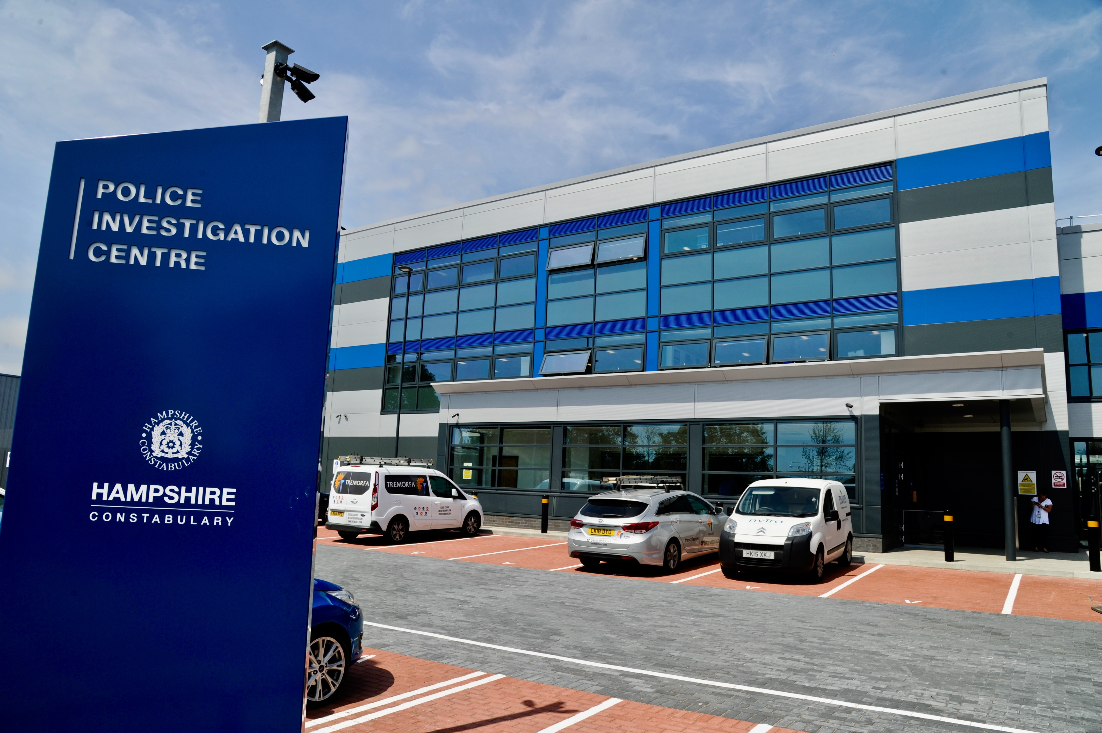

# Foreword



The report gives a real insight into the conditions for detained people in our custody suites. Independent Custody Visitors (ICVs) are volunteer members from the local community who share findings from their unannounced visits with my office. As one of my statutory responsibilities, I am committed to ensuring I have robust and efficient procedures to ensure an effective ICV scheme is in place.

ICV’s emphasise that they do not want or need to know why the detained person is there; they ask about their welfare, if they have been treated according to the law and if their rights and entitlements have been met. ICVs also provide a friendly smile and respectful impartial conversation.

This report covers May 2022 – April 2023. Independent custody visiting is an essential element of the work of my office, our scheme relies on the enthusiasm, commitment and dedication of our volunteer ICVs and I thank them all for their dedication. I am proud of what our Custody Visitors do towards increasing the public’s trust and confidence in Policing.

Donna Jones

Police and Crime Commissioner for Hampshire & Isle of Wight



**Contents**

Foreword 1

Executive Summary: Independent Custody Visitors (ICVs) in Hampshire and the Isle of Wight (HIOW) 1

Introduction 2

Governance of the Scheme 2

Scheme Manager and Coordinators 2

Volunteers 3

Custody Provision 3

Hampshire and Isle of Wight Constabulary Custody Data 3

Number of People Detained 4

Detainee demographics 5

Gender 5

Ethnicity 6

Detentions resulting in Released Under Investigation (RUI) or bail 7

Independent Custody Visiting data 8

Reasons for Non-Interview 9

Interview Offers and Uptake 10

Custody Record 11

ICV Reports and Concerns 11

Key Developments During 2022/2023 13

OPCC Restructure 2022 13

Internal Audit 13

Operation Safeguard 14

Quality Assurance Framework (QAF) 14

Police and Crime Commissioner Awards 2023 15

Further information and contact details 16

For further information about ICV Schemes 16

# Executive Summary: Independent Custody Visitors (ICVs) in Hampshire and the Isle of Wight (HIOW)

The consensus from Independent Custody Visitors (ICVs) is that Hampshire and the Isle of Wight should be proud of their custody suites and the treatment of detainees.

An ICV is a volunteer who visits detained people in custody in a police station. For many people, arriving in a custody suite can be a daunting and frightening experience, without being aware of their rights or entitlements. An ICV’s main responsibility is to check on the welfare of a detained person and ensure they are treated properly while in custody. An ICV ensures that a detainee understands their rights (under PACE[1]), why they are in custody, that they have access to free legal advice, and that they can contact someone to inform them of their whereabouts.

ICVs make unannounced visits to police stations at any time or day of the week, and can speak to anyone currently detained within the custody suite. ICV visits are always undertaken in pairs.

ICVs can inspect cells and the facilities within the custody suite for health and safety purposes. ICVs can also inspect the custody record which records everything that happens to a detainee whilst in custody. Issues identified by the ICV can initially be raised with the Custody Sergeant, or with the Custody Inspector if the matter cannot be remedied immediately or is of a serious nature. ICVs make a report of each visit highlighting any issues identified, and a copy is forwarded to the OPCC’s ICV Scheme Manager.

In 2022-2023 ICVs conducted 196 visits across Hampshire and Isle of Wight custody suites to check on the human rights and welfare of those detained in police custody. During this period there were over 24,000 detainees that went through police custody. ICVs interacted with over 1,600 of those detainees and spent more than 196 hours monitoring detainee dignity and safety in custody. Whilst visiting custody ICVs checked on 97% of children in custody and 95% of adult detainees.

# Introduction

Until the publication of the Scarman Report following the Brixton riots in 1981, no provision existed for the independent monitoring of the welfare of detainees held in police custody. Lord Scarman recommended that provision be made for random checks to take place in custody suites, by people other than the police, allowing independent review of the interrogation and detention of suspects in police stations[2]. The aim was to promote public confidence in policing, ensuring all policing activity was accessible and transparent to scrutiny by the public. The Independent Custody Visiting (ICV) provision was initially voluntary for Police Authorities until 2002[3] when it became a statutory provision for Police and Crime Commissioners.

ICVs in Hampshire and the Isle of Wight are recruited by the Office of the Police and Crime Commissioner (OPCC), but are independent of both the OPCC and Hampshire and Isle of Wight Constabulary. Custody visiting, formerly known as lay visiting, was established in 1983 and the Hampshire and Isle of Wight scheme began in 1987. The Police and Crime Act 2002, made custody visiting statutory and the Home Office introduced the ‘Code of Practice on Independent Custody Visiting’. The Police Reform and Social Responsibility Act 2011, introduced Police and Crime Commissioners and gave them the responsibility for operating and overseeing a scheme in their police force area.

# Governance of the Scheme

# Scheme Manager and Coordinators

A Scheme Manager, has oversight and coordinates the scheme and team of volunteers. The Scheme Manager is responsible for the recruitment, selection, vetting and appointment of ICVs. The Scheme Manager ensures that an adequate number of ICVs are available at all times across the policing area, and is responsible for the induction of new recruits to the scheme. The Scheme Manager is also responsible for initial and ongoing training in consultation with Hampshire and Isle of Wight Constabulary and the other volunteers.

The scheme is divided into four local panels which mirror Hampshire and Isle of Wight Constabulary’s four custody areas; these are Eastern (South East Panel), Isle of Wight (IOW Panel), Northern (Northern Panel) and Western (South West Panel). A Volunteer Panel Coordinator, who supports the Scheme Manager, leads each panel area. Panel Coordinators are responsible for the day-to-day running of each panel including providing training to new recruits to the scheme. Panel meetings occur four times a year and enable panel members to meet face to face with the Scheme Manager and Custody Inspector (or their Deputy) to express any concerns, identify areas of good practice and provide observations.

# Volunteers

Following a visit to a custody suite, ICVs produce a report for the Scheme Manager. Any areas for action which are unable to be addressed at the time of the visit are recorded and flagged to the Custody Inspector for action. If the ICVs are still not satisfied, they can raise the issue with the Scheme Manager at the OPCC who will liaise directly with the Custody Inspector.

# Custody Provision

Custody provision is divided into four areas, Eastern, Northern, Western and the Isle of Wight. The Eastern area consists of Portsmouth Police Investigation Centre (EPIC) with 36 cells. The Northern area consists of Northern Police Investigation Centre (NPIC) with 36 cells. The Western area consists of Western Police Investigation Centre with 36 cells, and the Isle of Wight consists of Newport Police Station with 11 cells. This totals 119 custody cells across Hampshire and Isle of Wight.

# Hampshire and Isle of Wight Constabulary Custody Data

Hampshire and Isle of Wight Constabulary is one of the largest non-metropolitan forces in the country, delivering policing services to a population of almost two million people. It is home to critical national infrastructure sites such as the ports in Southampton and Portsmouth and crucial oil refineries. Hampshire has a significant transport network including the M27 and M3, key rail hubs and two international airports.

The custody data provides a picture of Hampshire Constabulary’s police custody demand, highlighting the number of detainees, detainee demographics, the average waiting time in custody, the length of time a person is detained, and detentions resulting in bail or released under investigation (RUI) status.

# Number of People Detained

The data presented below is grouped into financial years.

In 2022/2023, 24,132 people were detained in police custody across Hampshire and the Isle of Wight. This is a 0.5% increase form 2022/2021 (24,016 people detained).

Number of people detained at the Police Investigation Centre (PIC) across Hampshire and the Isle of Wight:

*Figure 1: Number of people detained in HIOW by year and PIC*

The number of detainees across Hampshire Constabulary’s four PIC’s has remained relatively stable over the last three years. There has been a slight increase of 0.5% in the number of detainees in 2022/2023 (24,132) when compared to 2021/2022 (24,016 people detained).

# Detainee demographics

# Gender

In 2022/2023, males accounted for 84% (20,303) and females 16% (3,789) of all detainees across Hampshire and Isle of Wight. This custody gender split has remained relatively stable over the last three years:

When considering the gender split by PIC in 2022/2023, it is evident that this is relatively similar across all four PIC’s, with a slightly higher percentage of females and lower percentage of males in the Eastern Area:

*Figure 2: Gender split across HIOW PIC’s in custody per year*

Adult/Youth

*Figure 3: gender by PIC*

Young people under the age of 18 are recorded as ‘youth’.

# Ethnicity

Southampton and Portsmouth are amongst the largest cities in the UK and have greater numbers of ethnic minority communities and diversity when compared to the rest of Hampshire and the Isle of Wight. This is reflected in the custody data relating to ethnicity in 2022/2023.

*Figure 5: Ethnicity of detainees by PIC 2022/2023*

*Figure 5: Ethnicity of detainees by PIC 2021/2022*

# Detentions resulting in Released Under Investigation (RUI) or bail

April 2022 – March 2023, 7,581 detainees were bailed across HIOW four PIC’s. The below chart illustrates the number of people bailed and the bail rate by PIC:

*Figure 6: number of detainees bailed by PIC 2022/2023*

The Police, Crime, Sentencing and Courts Act 2022 (PCSC) was introduced to rebalance the use of pre-charge bail. It removes the presumption against bail, replacing it with a neutral position to encourage the use of pre-charge bail where necessary and proportionate in all of the circumstances of the case.

A further 5,280 people were Released under Investigation (RUI). To be RUI means that the person is released whilst the investigation is active but not subject to any bail conditions

The RUI rate is relatively similar across all four PIC’s, with Eastern PIC presenting a higher rate when compared to the other three PIC’s:

*Figure 7: number of detainees RUI by PIC 2022/2023*

# Independent Custody Visiting data

In 2022-23 ICVs conducted 194 visits across Hampshire and Isle of Wight custody.

*Figure 8: number of ICV visits by Panel 2022/2023*

During this period there were over 24,000 detainees that went through police custody. ICVs interacted with over 1,600 of those detainees and spent more than 196 hours monitoring detainee dignity and safety in custody.

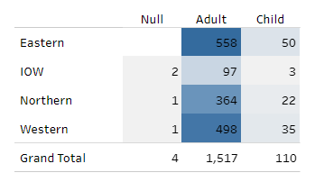

*Figure 9: number of detainees by PIC 2022/2023*

There were 1,627 detainees in custody when ICVs visited. The Eastern Police Investigation Centre had the most detainees as it has the highest footfall followed closely by the Western Police Investigation Centre.

# Reasons for Non-Interview

Of those 1,627 detainees in custody at the time of ICV visits 743 were not interviewed. In line with previous years, the top two reasons why a detainee was not interviewed by the ICV’s were they were asleep in their cell (331) or were being interviewed by police or with their solicitor (134).

The third highest reason (70 instances) for ICVs not interviewing detainees was detainees being released i.e. when the ICVs were in a position to interview the detainee, they had already been released from police custody.



# Interview Offers and Uptake

Overall 35 detainees refused a visit from ICVs. ICVs checked on 95% of adult detainees and 97% of children in custody at the time of their visits.

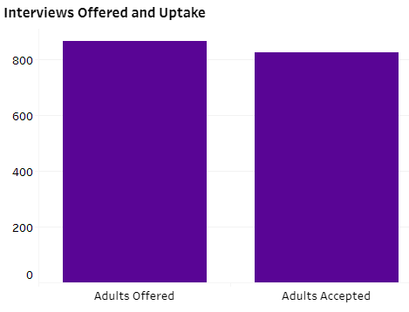

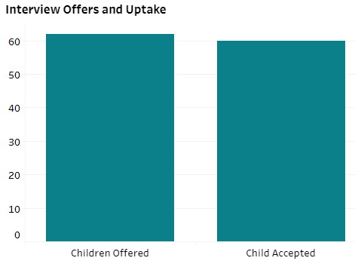

The number of people who were in detention during ICV visits was 1,627 (custody population), of these 928 were offered an interview and 884 detainees accepted the interview.

# Custody Record

The custody record is a detailed electronic log of everything that happens to a detained person during their detention in custody. During an interview with a detained person, if ICVs identify a concern, they are able to check the custody record with the detainee’s consent. ICVs with concerns about a detainee whom they cannot interview, can check the custody log without consent but must note the reason for doing this in their report, for example where ICVs believe a detainee to be particularly vulnerable e.g. a very young person or a detainee with mental health issues. ICVs reviewed custody records of 127 detainees.

# ICV Reports and Concerns

**Reports from custody visits:** Throughout the year ICVs have regularly commented on the exceptionally good care given by custody staff to detained people (DP). They highlight the genuine concern for welfare demonstrated by the staff. There have also been several very positive comments, particularly about the care of vulnerable detainees, young people, and detainees in custody for the first time.

**Police response:** The vast majority of issues raised by ICVs are dealt with informally between the ICVs and the custody staff, with clear protocols in place where a matter is unresolved, or a wider thematic issue is discovered.

As a result of conversations between ICVs and detainees, several requests were raised and shared with custody staff. This included requests such as additional drinks, blankets and to speak with solicitors, family members or health care professionals. ICVs have checked the custody records of detainees to look at allegations of the DPs not being given rights, offered contact or offered free and independent legal advice. In all cases the checking of the custody record shows that this was done by the custody officer during the booking in process.

It is noted by ICVs that almost without fail, the standards of care provided, and the respect and dignity offered to detainees is exemplary, but naturally some issues were highlighted.

**Delays in Authorisation –** ICVs report on any delay to adult detainee authorisation over an hour long and child detainee authorisation over 30 minutes long where there is no explanation recorded on the custody log. These are then reviewed at quarterly panel meetings. As a result of ICV reporting, custody staff were directed to record on the log the reason for any delay in authorisation.

**Appropriate adult service –** Whilst ICVs have been reassured by custody staff that AAs are excellent when in custody, some concerns were raised regarding occasional delays in attendance at the police station. This can cause delays in investigation and additional stress for detainees. Southampton and Portsmouth PICs operate an in-situ shift arrangement during busier hours, and outside of those hours all PICs request an Appropriate Adult on a call-out basis. The commissioned Appropriate Adult service is utilised where friends or family members are unable to attend. ICVs continue to monitor and report back on detainee access to Appropriate Adults.

**Storage of food** – ICVs continually check dates on food kept in police custody. Out of date food is removed to ensure that all food hygiene measures are met.

**Religious Materials** – ICVs highlighted that while custody suites hold good religious resources to address the needs and dignity of people of faith who are detained, there was an instance where a copy of the Hindu Gita was missing from the religious texts available. A copy was ordered and is now available in police custody.

**Shower facilities -** ICVs identified potential ligature points on shower locks, and this was reported to the central custody team and promptly resolved.

**Health Care provision in custody -** Out of hour’s provision for health care and liaison and diversion services have been a challenge for the Constabulary, and ICVs continue to report any issues.

# Key Developments 2022/2023

# OPCC Restructure 2022

Since the election of Police and Crime Commissioner Donna Jones, the office of the Commissioner is now leaner, more agile and efficiently able to deliver the priorities of the Police and Crime Plan.

As part of this restructure new roles were developed, one of the new roles introduced was Partnerships, Communities and Volunteers Officer, which includes management of the ICV scheme. The current ICV Scheme Manager took over the scheme in June 2022.

# Internal Audit

An internal audit was undertaken of the Independent Custody Visitor Scheme in October 2022.

The audit focused on ensuring that the Independent Custody Visitor scheme carried out visits on a sufficiently frequent basis to provide independent assurance to the OPCC on the welfare of detained persons and that the results of these visits were documented with corrective action taken where required. The audit also reviewed the guidance in place to support Independent Custody Visitors and the recruitment, training, and vetting process.

The audit assessed the following areas as working well with effective controls in place:

* An ICV Scheme Handbook is in place which provides guidance for all ICVs on their role, including statutory guidance as to how Independent Custody Visiting should be carried out.
* Scheme meetings are held quarterly by the Scheme Manager and are attended by the panel co-ordinators to report on matters relating to their area panel and other matters relevant to the scheme
* The Scheme Manager adds data from the ICV visit reports to an ICV visit tracker spreadsheet
* A diversity form is now completed as part of the recruitment process to check recruitment is representative against the population of Hampshire and the Isle of Wight
* Rotas reviewed from each of the panels showed that the correct number of visits have been scheduled for each quarter, in pairs of volunteers as per the scheme requirements.
* Quarterly returns are produced for the ICVA by the Scheme Manager providing details of the number of ICV visits undertaken and figures on numbers of detainees observed and agreeing to interview.
* The Handbook contains appropriate guidance around expenses, and these are in line with national guidelines.

The audit identified gaps, weaknesses or non-compliance in some areas. This included improvement to the system of governance, risk management and control, and to effectively manage risk to achieve objectives. It was evident during the review that the current Scheme Manager is aware of the gaps and is making improvements.

# Operation Safeguard

Operation Safeguard was an operation to temporarily house remanded prisoners in police custody to reduce pressure on prisons. This began in Hampshire at the beginning of March 2023 and a wing of Basingstoke Custody at the Northern Police Investigation Centre (PIC) was ring-fenced for Operation Safeguard prisoners.

A set of visiting procedures were implemented by the ICV Co-ordinator of the Northern Panel in consultation with ICVA and the Custody Team at the Northern PIC to visit prisoners held under Operation Safeguard.

All prisoners were treated in the same way as detainees with the exception of:

* Access to legal advice is normally provided when the prisoners reach prison, rather than in the custody suite
* Hampshire Liaison Diversion Service is not commissioned to support those prisoners
* There will be no additional visits to custody by ICVs, and monitoring of prisoners will be undertaken during routine visits. The ICVs prioritise those traditionally detained in police custody, with any further time available to support others

No people were held in the Basingstoke PIC under Operation Safeguard, and it was de-activated from May 2023.

# Quality Assurance Framework (QAF)

The Quality Assurance Framework (QAF) was introduced by the Independent Custody Visiting Association (ICVA) in April 2018. It enables schemes to reflect on how they comply with the Code of Practice and the legislation underpinning custody visiting. The QAF seeks to encourage schemes to celebrate areas of strength and achievement, promote custody visiting, drive performance and increase sharing of good practice.

Hampshire and the Isle of Wight ICV Scheme achieved the Code Compliant standard in 2021 and remained fully compliant with Home Office guidelines. ICVA have recently re-launched the QAF and the OPCC is seeking to achieve the Silver Award in 2023.

# Police and Crime Commissioner Awards 2023

The Police and Crime Commissioner’s Awards took place on 31st March 2023. The event was an opportunity for the Commissioner and her team to thank volunteers who work across the criminal justice landscape to make Hampshire and the Isle of Wight safer. Pauline Shorney who is now deputy Panel Co-ordinator on the Southampton Panel received the Police and Crime Commissioner’s Independent Custody Visitor of the year Award for being reliable, thorough and conscientious in carrying out her responsibilities. She has frequently stepped in, often at very short notice to provide cover when other visitors have been unable to carry out their visit and has, for several years continued to support the Portsmouth team while they embed new custody visitors.

**Collaboration:** The Hampshire and Isle of Wight ICV Scheme works alongside regional colleagues from the South East of England (Kent, Sussex, Surrey and Thames Valley).The Scheme Managers from these regions meet on a regular basis to share experience and best practice.

# Further information and contact details

If you would like any further information about the Hampshire ICV scheme or would be interested in becoming an ICV, please contact:

**ICV Scheme Manager**

The Office of the Police and Crime Commissioner for Hampshire, Unit 1, The Long Barn, Dean Farm Estate, Wickham Road, Fareham Common, Fareham, Hampshire, PO17 5BN

Tel: 01962 871595

Web: [www.hampshire-pcc.gov.uk](http://www.hampshire-pcc.gov.uk)

Email: opcc@hampshire.police.uk

Facebook: Police and Crime for Hampshire

Twitter: @HantsPCC and @HantsICV

For information about ICVA, please contact:

**The Independent Custody Visiting Association (ICVA)**

C/O Edwards and Keeping  
Unity Chambers  
34 High East Street, Dorchester  
Dorset

DT1 1HA

Web: <https://icva.org.uk/>

Email: [Info@ICVA.org.uk](mailto:Info@ICVA.org.uk)

# For further information about ICV Schemes

The Home Office Code of Practice on Independent Custody Visiting <http://bit.ly/ICVcodeofpractice>

The Independent Custody Visiting Association (ICVA) National Standards [www.icva.org.uk/publications](http://www.icva.org.uk/publications)

Association of Chief Police Officers Guidance on The Safer Detention and Handling of Persons in Police Custody 2nd Edition <http://bit.ly/ACPOguide>

Relevant legislation such as The Police and Criminal Evidence Act (PACE) Code C <http://bit.ly/PACEcodeC>

1. The Police and Criminal Evidence Act 1984
2. Lay Police Station Visitors - “I recommend provision for the random checks by persons other than police officers on the interrogation and detention of suspects in the police station” The Scarman Report: The Brixton Disorders
3. The Police Reform Act 2002