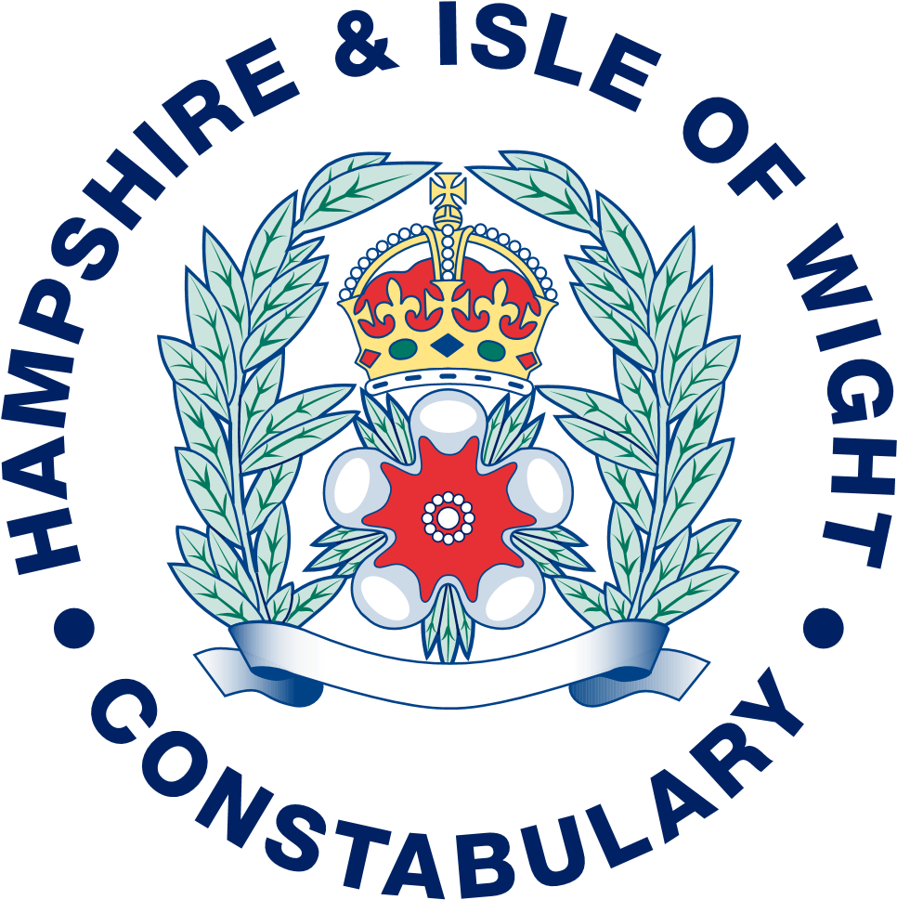

ANNUAL GOVERNANCE STATEMENT
2022/2023

FOR

HAMPSHIRE & ISLE OF WIGHT CONSTABULARY

Annual Governance Statement for Hampshire & Isle of Wight Constabulary

- Scope of Responsibility
1.1 Hampshire & Isle of Wight Constabulary is responsible for ensuring that:
- its business is conducted in accordance with the law and to proper standards.
- public money is safeguarded and properly accounted for, and used economically, efficiently and effectively.
- it secures continuous improvements in the way in which its functions are exercised, having regard to a combination of efficiency, effectiveness and economy.
- there is a sound system of internal control which facilitates the effective exercise of the Constabulary's functions and which include arrangements for the management of risk.

1.2 This Statement explains how the Constabulary has complied with its Code of Corporate Governance and meets with the requirements of the Accounts and Audit (England) Regulations in relation to the publication of an Annual Governance Statement.

- The purpose of Corporate Governance
2.1 The governance framework comprises the systems, processes, cultures and values by which the Constabulary is directed and controlled and its activities through which it accounts to, engages with and leads the community. It enables the Constabulary to monitor the achievements of the Constabulary’s strategic objectives and to consider whether those objectives have led to the delivery of appropriate, cost effective services.
2.2 The system of internal control is a significant part of the framework and is designed to manage risk to a reasonable level. It cannot eliminate all risk of failure to achieve policies, aims and objectives and can therefore only provide reasonable and not absolute assurance of effectiveness. The system of internal control is based on an ongoing process designed to identify and prioritise the risk to the achievement of the Constabulary’s policies aims and objectives, to evaluate the likelihood of those risks being realised and the impact should they be realised, and to manage them efficiently, effectively and economically.
2.3 The governance framework has been in place at Hampshire & Isle of Wight Constabulary for the year ending 31 March 2023 and up to the date of approval of the annual report and the statement of accounts.
2.4 The Constabulary has approved and adopted a Scheme of Corporate Governance, which is consistent with the principles of the CIPFA/SOLACE Framework ‘Delivering Good Governance in Local Government’. Agendas and minutes of the Joint Audit Committee are published on the website.
2.5 The CIPFA/SOLACE framework identifies seven principles of good governance:
- Behaving with integrity, demonstrating strong commitment to ethical values, and respecting the rule of law
- Ensuring openness and comprehensive stakeholder engagement
- Defining outcomes in terms of sustainable economic, social and environmental benefits
- Determining the interventions necessary to optimise the achievement of the intended outcomes
- Developing the entity’s capacity, including the capability of its leadership and the individuals within it
- Managing risks and performance through robust internal control and strong public financial management
- Implementing good practices in transparency, reporting and audit to deliver effective accountability.
2.6 The first two principles underpin the whole CIPFA/SOLACE 2016 framework and are implicit in the remaining five principles.
- Core Principles of good governance
  - Behaving with Integrity, demonstrating strong commitment to ethical values, and respecting the rule of law
    - The Constabulary's operates in an open and transparent way and the Chief Constable sets the tone for the organisation by creating a climate and culture of openness, support, and respect. The Constabulary has fully adopted the Code of Ethics and this is emphasised in its inclusion as one of the six key areas of focus set out by the Chief Constable.
    - The Constabulary is committed to the highest ethical standards and has adopted a governance framework to re-enforce this philosophy as well as procedures to investigate any issues should the need arise. The framework, policies and procedures are set out in the Constabulary’s Scheme of Corporate Governance. The Scheme of Corporate Governance demonstrates a comprehensive commitment on the part of the Constabulary to integrity, ethical values and the rule of law.
    - The Ethics Committee advises the Chief Constable on items that require ethical consideration and promotes the Code of Ethics within the Constabulary.
    - The Constabulary has an Environmental Strategy that promotes sustainability. Environmental factors are considered in force policies and procedures, for example, air travel.
    - The key governance legal powers and responsibilities within the Constabulary are set out in legislation and statutory guidance (especially the Police Reform and Social Responsibility Act 2011, Policing Protocol Order 2011, Revised Financial Management Code of Practice 2018 and Strategic Policing Requirement 2015), the Scheme of Consent and Delegation, Financial Regulations and Contract Standing Orders. These are referenced in the Scheme of Corporate Governance.
  - Ensuring openness and comprehensive stakeholder engagement.
    - The Chief Constable has set out the Constabulary’s purpose and six key areas of focus. The clear strategic aims of which are communicated on the Constabulary’s website and through various communications. This provides an operating model for business planning and is informed by various departmental and partnership strategies and priorities. The image below shows the purpose in the centre surrounded by the six key areas of focus:

    - The Constabulary has a clear governance framework for corporate decision making. Operational decision making is covered by standard practices and the use of decision logs. Corporate decisions are made at meetings that record key decisions and actions. Financial authorisations are recorded in the finance system and often supported by emails. It should be noted that some decisions that affect the Constabulary are made by the Police and Crime Commissioner. Police and Crime Commissioner decisions have clear guidance and protocols on decision making and templates for decision reports. All decisions are published, albeit that consideration is given to redacting some elements where this is necessary and proportionate.
    - Public consultation to inform decision making is undertaken where warranted. The Constabulary has access to consultation undertaken by the Police and Crime Commissioner as well as systematic data gathered from surveying of victims and the wider public. Social media provides further opportunities to engage and survey members of the public. Other consultation is undertaken such as via the Joint Audit Committee, Independent Advisory Group, Ethics Committee and local consultations.
  - Defining outcomes in terms of sustainable economic, social and environmental benefits.
    - The strategic aims set out in the purpose and six areas of focus underpin the Constabulary’s overarching ambitions for delivering positive economic, social and environmental outcomes under the purpose of ensuring Safer Communities for Hampshire and the Isle of Wight. The Constabulary must also have regard to the Police and Crime Plan, which also sets out the Police and Crime Commissioner’s vision, priorities and mission. The operational delivery against the Safer Purpose and Six areas of focus is tracked through the Force Performance Group held by the Deputy Chief Constable and the Police and Crime Commissioner holds the Chief Constable to account on a regular basis for the exercise of the functions of the Chief Constable and the functions of people under the direction and control of the Chief Constable (section 1.7, PRSRA 2011). The Chief Constable maintains operational independence.
  - Determining the interventions necessary to optimise the achievement of the intended outcomes.
    - Clear guidance and protocols exist for decision making and the involvement of legal and finance officers in all significant decisions of the Constabulary ensures that decisions are only made after relevant options have been weighed and associated risks assessed. Details of the guidance and protocols are set out in the Scheme of Corporate Governance.
    - Equality Impact Assessments (EIAs) are used to assess the impact of significant proposals and to inform decision making.
    - The budget setting process is well established and ultimately the budget is set by the Police and Crime Commissioner after proposals on the council tax precept are consulted upon with the public and scrutinised in public by the Police and Crime Panel. The budget is set in the context of achieving the Police and Crime Plan and the purpose of the Constabulary.
    - A medium term financial strategy, capital programme and reserves strategy is updated each year together with relevant resource forecasts and takes full account of the changing regulatory, environmental, demographic and economic factors that impact on the financial environment in which the Constabulary operates.
    - Risks associated with the achievement of intended outcomes are detailed in Risk Registers held at strategic corporate, portfolio and project level. These evaluate the effectiveness of existing control measures as well as identifying proposed mitigation.
  - Developing the entity’s capacity including the capability of its leadership and the individuals within it
    - The Constabulary places a significant value of the capability of leadership. Courses are run in-house and available externally, for example via the College of Policing. Each individual has a Personal Development Review on a regular basis with their line manager to ensure that any skill gaps are addressed and to discuss opportunities for development.
    - The Constabulary regularly reviews the shape of its workforce against the needs of the service in the context of its capacity and capability requirements. This then informs a range of strategies, for example; recruitment, retention and people development in order to provide effective leadership and deploy appropriate resources to meet the needs of services.
    - There is an emphasis on the need for high performance, of which resilience and continuous development play key parts, both of which factor in the regular discussions between managers and staff.
  - Managing risks and performance through robust internal control and strong public financial management.
    - The Constabulary operates a robust Risk Management Strategy, with oversight of those arrangements provided by the Risk and Learning Board and reports to the Joint Audit Committee. The Joint Audit Committee has provided significant guidance and advice for the enhancement of the risk management arrangements.
    - Each part of the Constabulary has its own Board to identify and manage risks within their part of the organisation and escalate those to the strategic risk register for consideration at the Risk and Learning Board where they meet the threshold.
    - Risks jointly held with TVP through collaborations are reviewed at the DCC Collaboration Board and PCC Collaboration Board.
    - The Internal Audit Plan provides the mechanism through which the Chief Internal Auditor can ensure most appropriate use of internal audit resources.
    - The Internal Audit Plan was developed to operate at a strategic level providing a value adding, and proportionate, level of assurance aligned to the Constabulary’s key risks and objectives. This includes a periodic review of the Constabulary’s risk management processes.
    - The Audit Plan remains fluid to ensure Internal Audit’s ability to react to the changing needs of the Constabulary.
    - The Internal Audit Plan incorporates provision for both proactive and reactive counter fraud and corruption work, which is underpinned by an embedded Counter Fraud & Corruption Strategy and Policy and Anti Bribery Act Policy.
    - The delivery of the Internal Audit Plan enables the Chief Internal Auditor to provide an annual report providing an opinion on the overall adequacy and effectiveness of the framework of governance, risk management and control which is reported to the Joint Audit Committee, Police and Crime Commissioner and Chief Constable.
    - The Joint Audit Committee is well established and provides independent advice to the Chief Constable and Police and Crime Commissioner. Members of the Joint Audit Committee have no executive responsibility for the management of the organisation, thus ensuring that they are sufficiently independent to scrutinise and challenge matters brought to their attention. This year, the Committee has been provided with an allowance and training budget, enabling members to attend internal meetings of both the Constabulary and the OPCC to observe decision making processes in action.
    - The Joint Audit Committee has a clear ‘Terms of Reference’ providing an effective source of scrutiny, challenge and assurance regarding the arrangements for managing risk and maintaining an effective control environment. The terms have been reviewed this year to extend the maximum tenure of the Chair, recognising that the current tenure length would have a negative impact on the efficient operation of the Committee.
    - The Constabulary has a well-developed and effective scrutiny function via the Police and Crime Commissioner.
    - The Constabulary has strong financial management arrangements at both the strategic and operational level and consistently obtains unqualified opinions for its annual accounts and value for money assessment. The Section 151 Officer is a member of the Chief Officers Group and Force Executive. All formal financial decision making has the benefit of the advice and review of the Chief Financial Officer or their representative.
    - Key financial regulations and financial strategies form an important part of the Corporate Governance Framework together with effective risk based financial and performance reporting.
    - Financial management in key risk areas across the Constabulary focusses on activity and performance management alongside the budget management processes and the financial management framework throughout all tiers of the organisation is appropriately advised and supported by the Finance function.
    - The real risk of cyber-attack continues to grow in UK Policing not just from criminal organisations but also state actors, in response during 2022/23 we have implemented a Cyber Threat & Response Management Board to provide a comprehensive bilateral response to our cyber threat & response position ensuring agreed and appropriate solutions and remediation plans are in place and actively progressing additionally, informing Force(s) Executive of strategic outcomes and ensuring learning activities are cascaded to respective departments.
  - Implementing good practices in transparency reporting and audit to deliver effective accountability.
    - The decision making guidance, protocols and templates referred to in the Scheme of Corporate Governance and the involvement of senior officers, legal officers and finance officers ensures that public reports are written in a clear and accessible way with sufficient information to enable members of the public to formulate informed opinions on the matters for decision.
    - The corporate Force Performance Group framework provides a transparent cycle of reporting on core performance metrics. Performance information is published online and is easily accessible to staff, partners and the public.
    - The ‘Internal Audit Charter’ is presented annually for review by the Joint Audit Committee. The Charter makes provision that where it is considered necessary to the proper discharge of the internal audit function, the Chief Internal Auditor has direct access to the Joint Audit Committee.
    - The ongoing work of internal Audit is presented through a quarterly progress report to the Joint Audit Committee providing an overview of service performance; delivery against the plan; and progress made by the organisation in the implementation of management actions agreed to mitigate risks identified through internal audit work.
    - Representatives of External Audit routinely attend Joint Audit Committee meetings and present all External Audit reports. Any recommendations for corrective action detailed within External Audit reports are highlighted to the Joint Audit Committee who will track through to implementation. This is achieved through the clear and concise nature of the minutes to each meeting.
    - The Internal Audit Plan includes provision to review the Constabulary’s approach to governance, risk and controls for partnership working. Such reviews are formally reported through the Joint Audit Committee with any significant issues highlighted accordingly.
    - Where appropriate Internal Audit will gain assurances from third parties to contribute to their overall assurance opinion.
- Obtain assurances on the effectiveness of key controls
  - Key controls relating to risks, internal control (including financial management), and governance processes are identified by managers as part of the governance framework and recorded on risk registers. These are consolidated into the strategic risk register at a corporate level.
  - Internal Audit, as part of its planned review of internal controls regularly evaluates the key controls to determine their adequacy and also carries out tests to confirm the level of compliance. Together the results of each review enable an audit opinion on effectiveness to be provided to management, and any actions for improvement to be agreed.
  - External sources of assurance include the annual opinion and value for money conclusion by external auditors, and statutory inspections by Her Majesty’s Inspector of Constabulary and Fire and Rescue Service (HMICFRS). These reports are subject to consideration by senior management and appropriate responses are agreed to any recommendations for improvements. The reports are normally approved in public and published. External sources of validation are being increasingly used to inform assessment of the organisations performance.
  - In conjunction with specialist Internal Audit support, the Constabulary has also applied the CIPFA Counter Fraud self-assessment tool to identify potential opportunities for enhancement.
  - The Constabulary must comply with the CIPFA Financial Management Code. The FM Code is a self-assessment of financial management within an organisation. The Code is written with Councils in mind and therefore we have been informed by CIPFA that police organisations will need to make their own common sense adjustments to the requirements of the Code to make it relevant for policing and that some sections will need to be disregarded. There is no guidance on the level of evidence that is required to support this assessment, but a desktop exercise performed drew the conclusion that the Constabulary is compliant with the principles of the FM Code. The FM Code process was subject to an internal audit review which reported a ‘substantial’ audit opinion.
- Evaluate assurances and identify gaps in control/assurance
  - The Constabulary has made adequate arrangements to identify, receive and evaluate reports from the defined internal and external assurance providers to identify weaknesses in controls.
  - Reports on collaborated functions are received from the host force. Reports in relation to IT and Information Management are received from the Thames Valley Police internal auditor. These are reported to the Joint Audit Committee and incorporated by the Chief Internal Auditor into the annual internal audit opinion. Queries and concerns will normally be resolved during the course of the Joint Audit Committee through the attendance of the Thames Valley Police internal auditor. If there are any outstanding queries, the Police and Crime Commissioner and Chief Constable can raise those through the Collaboration Board.
  - Each board within the Constabulary has assessed risk and reported significant risks via the governance framework for inclusion within the Strategic Risk Register. The Internal Audit Plan and reports have assisted the assessment of risk in business areas that are higher risk.
  - The Constabulary has responsibility for conducting, at least annually, a review of the effectiveness of its governance framework including the system of internal control. The review of effectiveness is informed by the work of the officers within the Constabulary who have responsibility for the development and maintenance of the governance environment, the Chief Internal Auditor’s annual report, and by comments made by the external auditors and other review agencies and inspectorates.
  - The Chief Internal Auditor has evaluated the reports from the internal and external assurance providers which have also been reported to the Joint Audit Committee. This Annual Governance Statement sets out the Constabulary’s arrangements for receiving reports and identifying weaknesses in internal control.
  - In line with the Internal Audit Charter, the key elements of the corporate governance framework are risk assessed and reviewed periodically by Internal Audit.
- Action plan to address weaknesses and ensure continuous improvement of the system of corporate governance

  - Scott Chilton became the new Chief Constable of Hampshire and the Isle of Wight Constabulary on 23 February 2023. The timing of the change meant that there was little impact to the governance arrangements for 2022/23. However, during 2023/24 there are expected to be some changes that will require delivery and oversight. This includes a review of the six areas of focus which are expected to be replaced.
  - The operating model for the Constabulary will move from a functional model to a more geographic model for the delivery of local policing. This measure is expected to create more local accountability that enables better operational performance.
  - Contact Management response times for non-emergency 101 calls were outside of the target time in 2022/23. Operation Fleck is addressing issues, including significant vacancies in the 101 call handling centre. Funding has also been approved in the 2023/24 budget for new software that will allow victims and witnesses for ongoing investigations to access officers involved in their cases directly without the need to go through the 101 service. If this is successful, it should result in a better service for those victims and witnesses and reduce the number of calls to 101.
  - The Constabulary has given formal notice to Hampshire County Council that it will remove non-transactional services for Finance, HR and property management from Shared Services. The majority of the recruitment function will also transfer to the Constabulary. Transactional services for Finance and HR (e.g. payments to third parties and payroll) will remain in the Shared Services Integrated Business Centre.
  - The Home Secretary announced that police officers will be able to join policing through a non-degree route. Work is underway to create a route that will enable the Constabulary to recruit some officers through a non-degree route.

- There is a robust mechanism to ensure that an appropriate action plan is agreed to address identified control weaknesses and is implemented and monitored

In response to the Action Plan identified in the 2021/22 Annual Governance Statement:
  - COVID 19 and the ongoing implications of it, still carry some risk but there was no adverse impact on the operational delivery, financial position or governance arrangements as a result of COVID-19 in 2022/23.
  - The Constabulary has successfully delivered the increase in officers required in 2022/23 to meet the Uplift target and claim the full amount of grant available. Furthermore, the Constabulary has achieved an additional 59 officer target above the original Uplift target number that allows the Constabulary to claim a further £1.180m on a one-off basis.
  - Operation Olympus was implemented in 2022/23. The main feature is the Falcon teams that process detainees for formal actions. This has resulted in an improvement of formal outcomes but more improvement is required so further actions are being taken, for example, the change of the operating model.
  - The Contact Management Platform (CMP) continues to be used for managing 999 and 101 calls into the Constabulary. The new digital support team is in place to bring together the development of CMP, the force crime recording system RMS and Pronto to maximise the return on these investments. However, vacancies in Contact Management mean that although the 999 emergency call performance is meeting the required standards, the 101 non-emergency service can be subject to long answering times. The 2023/24 budget contains approved funding for a recovery plan that will deliver a technology solution to assist.
  - The changes needed to better control the payment of acting up allowances are now in place and will continue to be subject to audit review.

Declaration
We have been advised on the implications of the result of the review of the effectiveness of the governance framework by the Joint Audit Committee and that the arrangements continue to be regarded as fit for purpose in accordance with the governance framework. The areas already addressed and those to be specifically addressed with new actions planned are set out in this Statement.
We propose over the coming year to take steps to address the above matters to further enhance our governance arrangements. We are satisfied that these steps will address the need for improvements that were identified in our review of effectiveness and will monitor their implementation and operation as part of our next annual review.

Signed: Signed:

Chief Constable Chief Finance Officer
Date: Date:

