Hampshire Independent Custody Visitor Scheme
  - Annual Report
  - 2020/2021
Foreword
The Independent Custody Visiting Scheme is a voluntary arrangement that provides an essential service to Hampshire and the Isle of Wight Police and Crime Commissioner.
The year covered by this report has been like no other. It has been dominated by the COVID pandemic, associated lockdowns and the implementation of strict protocols to counteract cross contamination and the spread of the virus.
Throughout this policing continued and although there was a 10% drop in the number of people detained in custody the requirement for detainees to be visited by Independent Custody Visitors continued. Face to face visiting was suspended for the first nine weeks within this report covers, remote monitoring took place in the meantime. This enabled us to formulate a protocol that ensured the safety of our ICV’s during visits and included social distancing and Personal Protective Equipment and a specific Risk Assessment.
Our Scheme is dependent on the commitment, professionalism and quality of the volunteers who give up their time, despite the pandemic, to keep the scheme going. Visitors provide a crucial level of scrutiny and assurance that potentially vulnerable people are looked after and supported while in custody.
Volunteers in this scheme demonstrated excellent standards of service throughout this difficult time. The role of visitors is crucial to ensure that our custody suites remain safe, particularly for detainees with complex needs and vulnerabilities.

Introduction
Until the publication of the Scarman Report following the Brixton riots (1981), no provision existed for the independent monitoring of the welfare of detainees held in police custody. Lord Scarman recommended that provision be made for random checks by people other than police officers on the interrogation and detention of suspects in police stations. The aim of this was to promote public confidence in policing, ensuring all policing activity was accessible and transparent to scrutiny by the public. The Independent Custody Visiting (ICV) provision was initially a voluntary one for police authorities until 2002 when it became a statutory provision.
ICVs in Hampshire and the Isle of Wight are recruited by the Office of the Police and Crime Commissioner (OPCC) but are independent of both the OPCC and Hampshire Constabulary.
ICVs make unannounced visits to police stations at any time or day or night and can speak to anyone detained within the custody suite at the time of the visit.
Custody visiting, formerly known as lay visiting, was established in 1983 and the Hampshire and Isle of Wight scheme began in 1987. The Police and Crime Act (2002) made custody visiting statutory and the Home Office introduced the ‘Code of Practice on Independent Custody Visiting’. The Police Reform and Social Responsibility Act (2011) introduced Police and Crime Commissioners and gave them the responsibility for operating and overseeing a scheme in their police force area.
An ICV is a volunteer who visits people that have been detained in custody in a police station. For many people, arriving in a custody suite can be a daunting and frightening experience without being aware of their rights or entitlements. An ICV’s main responsibility is to check on the welfare of a detained person and make sure they are being treated properly while in custody. An ICV ensures that a detainee understands their rights (under PACE), why they are in custody, that they have access to free legal advice, and that they can contact someone to inform them of their whereabouts.
ICVs can inspect cells and the facilities within the custody suite for health and safety purposes. ICVs can also inspect the custody record, which is a record of everything that happens to a detainee whilst in custody. If an ICV discovers any issues, these can initially be raised with the custody sergeant present or, if the matter cannot be remedied immediately or is of a serious nature that requires senior attention, with the custody inspector. ICVs make a report of each visit highlighting any issues discovered, and a copy of the report is then forwarded onto the OPCC’s ICV scheme manager. Visits are always undertaken in pairs.
The Hampshire ICV scheme comprises of 37 volunteers, 21 of whom are women and 16 are men, ranging from 31 to 70+ in age. The majority of volunteers (34) identify as white British.

Custody provision
Custody provision within Hampshire is divided into four areas, Eastern, Northern, Western and the Isle of Wight. The Eastern area consists of Portsmouth Police Investigation Centre (EPIC). The Northern area consists of Basingstoke Police Investigation Centre (NPIC). The Western area consists of Southampton PIC and the Isle of Wight consists of Newport police station. In total there are 119 custody cells in Hampshire which are located as follows:

Eastern Area
Portsmouth PIC 36 cells
Isle of Wight
Newport 11 cells
Northern Area
Basingstoke PIC 36 cells

Western Area
Southampton PIC 36 cells

The scheme is divided into four local panels which mirror Hampshire Constabulary’s four custody areas, these are Eastern (South East Panel), Isle of Wight (IOW Panel), Northern (Northern Panel) and Western (South West Panel). A coordinator who supports the scheme manager leads each Panel.
Governance of the Scheme

Scheme manager and coordinators
A scheme manager, employed by the OPCC, manages the scheme. The scheme manager is responsible for all the recruitment, selection and appointment of ICVs. The scheme manager ensures that an adequate number of ICVs are available at all times and is responsible for the induction of new recruits to the scheme.
The panel coordinators are responsible for the day-to-day running of each panel including providing training to new recruits to the scheme. Panel meetings occur four times a year and enable panel members to meet face to face or virtually due to the pandemic with the scheme manager and custody inspector (or their deputy), to express any concerns or observations they may have.
Reports and concerns
Following a visit to a custody suite, ICVs produce a report which is then forwarded to the scheme manager. Any areas for action which are unable to be addressed at the time of the visit are recorded and flagged to the custody inspector or a more senior officer through the chain of command. If the ICVs are still not satisfied, they can raise the issue with the scheme manager at the OPCC who will liaise with the custody inspector at quarterly meetings or directly with the head of custody for Hampshire Constabulary.
Joint interim Interview Protocol- This was introduced by the Home Office as a method to provide remote legal advice during the pandemic. Legal representation was provided by telephone or video link to protect all parties and minimise the risk of infection. Face to face legal representation was only provided in exceptional circumstances for serious offences.
Pixilation of Toilet Areas- ICV’s were concerned that not all detainees were advised about the pixilation of the toilet areas. This was raised at the quarterly meetings and fed back to custody staff who made a concerted effort to improve in this area.
Special Diets – during visits on separate occasions, ICVs spoke to detainees who followed a strict vegan diet, were diabetic or were gluten intolerant. ICVs highlighted this to the custody staff, while staff were aware of these requirements there was some confusion over the detainees' specific needs, but due to the intervention of the ICVs, the staff purchased suitable food for the detainees. The opportunity was taken to highlight to all staff the process surrounding purchasing meals for special diets.
Storage of food – It was observed by one team that the refrigerator used to store food for detainees was not within the correct temperature range. This was rectified by staff and is now monitored across the county.
Length of Stay – Concerns were raised over the time some juveniles were spending in custody due to perceived delays in police officers accessing charging decisions from the Crown Prosecution Service (CPS). Custody officers must, and do, prioritise the care of juveniles but the CPS process does not and therefore officers were in long telephone queues to get CPS advice. This matter was highlighted to CPS and in response a new process is being trialled, regarding accessing CPS advice much more quickly for juveniles, to date the situation appears to have improved.
Religious Materials – ICVs highlighted that while custody suites held excellent religious resources to address the needs and dignity of people of faith who are detained, their storage in some cases was not respectful or equal. As a result, custody arranged for improved storage location, shelving be provided, ensure all texts remained in good condition and were stored equally well. Custody officers now also check each text (where appropriate) after use for damage.
Sleeping Reviews – While a person is in custody, the Inspector (as dictated by Police and Criminal Evidence Act) reviews their detention at specific time intervals. These reviews can occur whilst a detainee is asleep. Upon waking, the detainee must be informed that a review took place and advised of its outcome. This should be recorded in their custody record. On at least two occasions, although the reviews were undertaken at the correct times, they had not been properly communicated to the detainee on waking or if they had, had not been recorded appropriately in the records highlighted by ICVs. ICVs continue to track every instance and the findings collated and fed back to the police at regular intervals, ensure accuracy of records. During 2020/21, ICVs commented on the successful and timely communication of 201 sleeping reviews, but the failure to do so on a further 2 occasions. This is a marked improvement on the previous year.
Clothing – Anti-rip clothing including underwear and socks are provided to detainees to ensure their dignity if needed.
Hygiene - Hand Sanitizing stations have been installed at all entry points to custody. Detainees are routinely given access to soap and hot water.
Detainees are now being notified of the shower facilities on arrival.
Fresh PPE is provided to detainees each time they are moved around in custody.
ICVs regularly comment on the exceptionally good care given by custody staff to detainees. They highlight the genuine concern for welfare demonstrated by the staff and the desire for people to leave custody in a better position than when they arrived.
Hygiene- Hand sanitizing stations have been installed at all entry points to custody suites. Detainees are routinely given access to soap and hot water. Detainees are now being notified of the shower facilities on arrival.
PPE is provided to detainees while they are moving around custody.
Distraction materials are offered to detainees, these include reading materials, fidget spinners, puzzles and colouring books.
The consensus from all ICVs is that Hampshire should be proud of their custody suites and the treatment of detainees. One ICV wrote, “I have been impressed by the professionalism and dedication of Hampshire Police’s custody staff who do a very difficult job with dignity and respect.”
Another ICV said, “I have found custody staff to be helpful, cheerful and welcoming. Such a wonderful positive change from some public opinions.’’
When questioned about the reception of the volunteers into custody by either the officers or detainees, all responders commented positively which is essential to the smooth running of a successful scheme.
“All custody staff are welcoming to ICVs and willingly take the time to talk to us and answer our questions. Most detainees have recognised the important role of the ICVs and welcomed the opportunity to talk to an independent party.”
Another ICV commented, “I respect the cooperation of custody staff to tell us about challenges and concerns they face and their willingness to take action on our feedback. They see us as an important part of the custody process, who can celebrate their successes as well as highlight areas to improve.”

Covid-19
During this reporting period, the global Covid-19 pandemic has had significant impact on custody visiting nationally. The Home Office has granted ICV’s key worker status (26 March 2020), and the PCC offered all ICV’s the choice of whether or not they wished to continue with face-to-face visits.
The PCC has a statutory duty to maintain oversight of custody in some form, a mixture of face-to-face visits and remote fact-finding questionnaires between custody officers and the scheme manager were put in place under the governance of ICVA. To provide the necessary oversight and provide reassurance to the PCC and ICVs. To date this new system has worked effectively and has been well received by all parties.
During 2020/2021, the ICVs conducted 208 visits to Hampshire’s various custody suites. The IoW panel conducted 52 visits, including a Christmas Day and New Year’s Day visit. All mainland panels also conducted 52 visits each.
The earliest visit took place at 06:30 am and the latest visit took place at 22:31 pm.
This is of importance as it could be argued that those under the influence of alcohol or drugs may be more vulnerable and therefore observing how the Constabulary are dealing with higher volumes of vulnerable detainees may be beneficial. If detainees are unable to be interviewed, visitors are able to observe other processes (with the consent of the detainee) as well as spend more time checking custody logs.

The most visits took place jointly on Monday, Tuesday, Wednesday and Thursday with one hundred and fifty-nine visits undertaken by ICVs on these four days. Twenty-two visits took place on Friday, seventeen on a Saturday, with ten visits being undertaken on a Sunday.

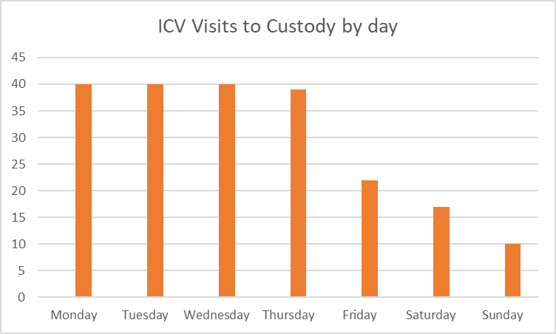
Figure 1: Visits conducted by day of the week
The number of people who were in detention during ICV visits was 1,380 (custody population), of these 1,109 were offered an interview of which 1,079 detained persons were interviewed. The uptake rate of those who accepted and were interviewed was 97%, which is higher than last year at 92%.
The number of people interviewed represents 5.2% of the entire custody population (20,794) in 2020/21. In total 276 people (20%) of the custody population at the time of the visit were not interviewed. In line with previous years, the top two reasons why a detainee were not interviewed by the ICV’s were they were asleep in their cell or were being interviewed alongside their solicitor. The reasons why detainees were not interviewed are listed below:

AA=Advised Against
AA- Alcohol=2
AA- Infection=8
AA-Mental Health=6
AA- Verbally abusive=1
AA-Violent=3
Asleep=60
At Hospital/With Health Care Professional=5
On interview /with solicitor=36
No English=21
Refused=6
Released=9
Undergoing a process=14
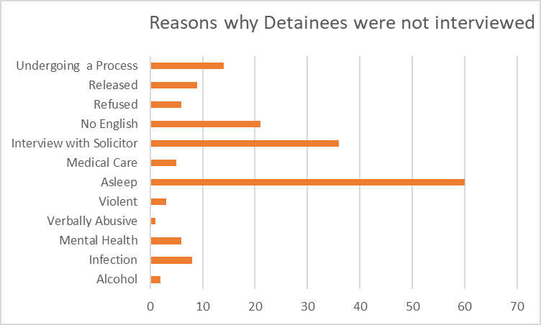
Figure 2: Reasons detainees declined an interview

Custody record
The custody record is a detailed electronic log of everything that happens to a detained person during their detention. During an interview with a detained person, if ICVs identify a concern, they are able to check the custody record but must gain the detainee’s consent to do so. However, ICVs with concerns about a detainee whom they cannot interview can check the custody log without consent but must note the reason for doing this in their report. This is done if ICVs believe a detainee to be particularly vulnerable i.e., a very young person or a detainee with mental health issues. Therefore, in addition to those interviewed face to face, ICVs checked the custody logs of 55 detainees whom they were not able to talk to, which included children and young people, vulnerable adults and those who could not speak English.

Detainee numbers
The combined population of Hampshire and the Isle of Wight is just under 2 million residents (1.9m), of which 2% of the population were detained in custody. The number of people detained in custody in 2020/2021 was 20,749 a decline compared with the previous year. There were 2399 fewer people in custody in 2020/2021 compared with 2019/20, a reduction of 10%, this is mainly attributable to the lockdown periods. The number of people detained in custody has fallen year on year over the last three years.
The figures below show the decline in custody population in Hampshire for the previous three years.
In 2018/2019 there were 2,3634 detainees
In 2019/2020 there were 2,3148 detainees
In 2020/2021 there were 2,0749 detainees

Detainees by custody suite
The three biggest crime types for which individuals were arrested and brought into custody were violence against the person, theft offences, and criminal damage. This represents a clear balance between the high threat and risk of harm offences and volume offences which impact the public.
The figures below show the footfall in Hampshire’s custody suites broken down by the four areas and the percentage variance over three years. There has been a predictable drop in footfall at all custody centres during lockdown.
Southampton, Portsmouth and Basingstoke have larger numbers of ethnic minority communities and diversity which is reflected in the custody ethnicity data in table 1 below. The percentage of black people detained in the East, North and West ranged between 4% - 10% whilst the percentage of Asian detainees ranged between 2% - 6%.
2020/21 | White | Black | Asian | Arabic/North African | Other/not stated | Totals
East | 6559 | 471 | 152 | 81 | 37 | 7300
IOW | 1296 | 32 | 5 | 4 | 6 | 1348
North | 4492 | 412 | 171 | 38 | 51 | 5104
West | 6007 | 606 | 364 | 45 | 25 | 7047
Totals | 18294 | 1521 | 692 | 168 | 119 | 20794
Table 1: Ethnicity of detainees

Sex
The overwhelming majority of detainees in Hampshire’s custody suites were males, who accounted for 85% of all detainees. The figures below illustrate the breakdown of sex of all those detained.
Male = 19545
Female = 3585
Not Stated = 18
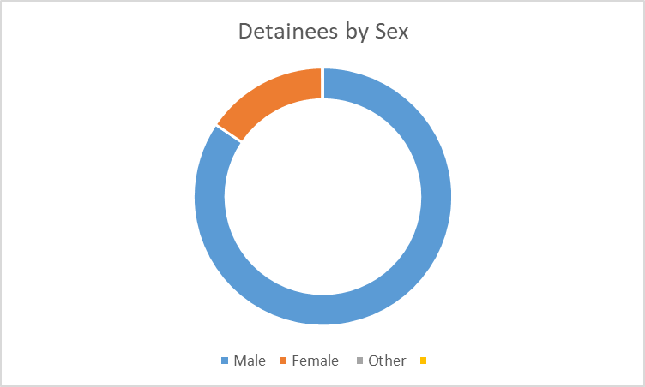
Figure 3: Detainees by sex

Age
The number of detained children and young people aged 17 and younger decreased compared to the previous year. The figure fell by 462 people or 23% in 2020/2021. The figure for the number of adults (18 and above) who were detained also decreased compared with the previous year, by 1,898 people or 8.9%.
17 and under = 1,544
Adult = 1,8240

Scheme Highlights

Quality Assurance Framework (QAF)
The QAF was postponed until March 2022 due to COVID19, the Hampshire Scheme remains fully compliant with the Home Office guidelines.

The Annual Seminar
An abridged version of the annual Hampshire ICV scheme seminar took place virtually on 19th September 2020. The event is part of the volunteers’ continuous professional development programme. It is an opportunity for all the ICV to share good practice and their experiences of being part of the scheme, and to receive updates on any changes which may impact on them as scheme volunteers, such as changes in legislation.
The volunteers who attended the event were welcomed by Deputy Chief Executive Enzo Riglia and received an update on custody from Inspector Andy Maynard, Custody deputy lead for Hampshire. Presentations on Video Enabled Justice in Hampshire Custody and work in the Police College Training from Inspector Tony Maggs (the Constabulary’s Estates and training lead), a presentation from Sherry Ralph (ICVA) on detainee dignity in custody.

Safer Awards
The Police and Crime Commissioner’s Safer Awards event took place virtually in December. The event was an opportunity for the Commissioner and the OPCC team to thank volunteers who work across the criminal justice landscape to make Hampshire and the Isle of Wight even safer. The IoW Panel won the team of the year award. This is the first time this has been awarded.

Review of Sleeping Arrangements
An amendment was made to PACE which stated that detainees should be informed at the first opportunity that a sleeping review has been conducted and should also be noted on the custody record. The ICV’s have been doing spot checks to ensure that this is happening. Freshly cooked food for detainees is now provided at all mainland custody centres.

The pandemic
Custody could not stop operating during the pandemic so fast and significant changes to working practices had to be introduced immediately.
Cleaning staff were responsive to the COVID situation and provided a high standard of cleanliness within detention areas and cells. Good wellbeing for detainees has been reported throughout the year, detainees had blankets, food and water.
ICV’s have checked that COVID measures are being adhered to. Detainees masks are not now being hung on door handles, but a fresh mask issued on each requirement. Increased COVID-19 PPE/SAFER spot checks by ICV Scheme manager at all custody suites.

Standards
The Hampshire ICV scheme has been improving year by year and is aspiring to achieving gold accreditation under ICVA’s Quality Assurance Framework 2, which is assessed bi-annually; the next QAF will be launched in March 2022.
Six schemes across the UK have participated in a pilot to try new methodologies for monitoring custody. The Independent Custody Observers Pilot (or ICOP) asks ICVs to look through complete custody records to monitor both the record and detainees treatment. This custody record review, returned data about a detainee’s complete journey through custody and reveals issues and challenges that schemes were not previously able to see. These reviews, coupled with enhanced visits, created a dynamic and enhanced means to monitor custody and help to prevent harm as required by the UK’s international human rights obligations. Independent evaluators have been with ICVA throughout the pilot and they have worked with the Home Office to respond to their recommendations. The Observers programme will be rolled out in Hampshire and the IoW from March 2022.
The recruitment and progression of volunteers is an important factor in the development and success of the scheme. The recruitment of new ICVs is an annual process which helps to maintain the schemes dynamism. There are currently four volunteers undergoing clearance.
Members of the scheme are further supported through the provision of annual workshops and training, to prevent complacency and ensure skills and expertise of the scheme volunteers remain up to date.
Work has continued throughout 2020/2021 to raise awareness about the benefits of the scheme and the essential work that volunteers carry out. Visitors continue to provide public reassurance that detainees are treated as they should be whilst in custody. This will involve increased use of social media as well as getting out into local community groups to deliver presentations about the scheme, when practical.

Further reading
https://www.gov.uk/government/publications/deaths-and-serious-incidents-in-police-custody https://www.gov.uk/government/organisations/lammy-review
https://www.gov.uk/government/publications/the-stephen-lawrence-inquiry

Further information and contact details

ICV Scheme Manager
The Office of the Police and Crime Commissioner for Hampshire
St George’s Chambers
St George’s Street
Winchester
SO23 8AJ

Tel: 01962 871595
Mob: 07795 335033

Web: www.hampshire-pcc.gov.uk
Email: opcc@hampshire.pnn.police.uk
Facebook: Police and Crime for Hampshire
Twitter: @HantsPCC and @HantsICV

The Independent Custody Visiting Association (ICVA)
C/O Edwards and Keeping
Unity Chambers
34 High East Street, Dorchester
Dorset
DT1 1HA

Web: https://icva.org.uk/
Email: Info@ICVA.org.uk

For further information about ICV Schemes
The Home Office Code of Practice on Independent Custody Visiting http://bit.ly/ICVcodeofpractice

The Independent Custody Visiting Association (ICVA) National Standards www.icva.org.uk/publications

Association of Chief Police Officers Guidance on The Safer Detention and Handling of Persons in Police Custody 2nd Edition http://bit.ly/ACPOguide

Relevant legislation such as The Police and Criminal Evidence Act (PACE) Code C http://bit.ly/PACEcodeC and The Human Rights Act (1998)

Lay Police Station Visitors - “I recommend provision for the random checks by persons other than police officers on the interrogation and detention of suspects in the police station” The Scarman Report: The Brixton Disorders
The Police Reform Act 2002.
The Police and Criminal Evidence Act 1984

