Worry eaters

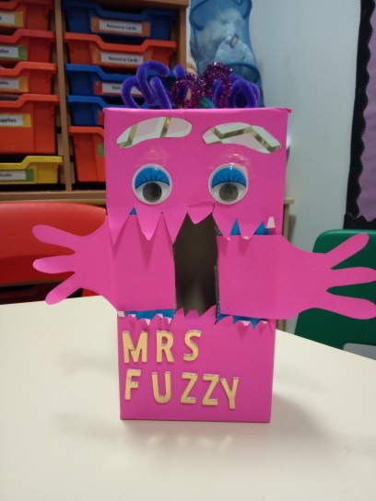
Make your own worry eater.
Here is an example of a worry eater/monster. All you need to make you own worry eater is an empty tissue box and anything you can find to decorate your worry monster.

We’ve included some images you may want to use if you don’t have any arts & crafts supplies. Otherwise you can just cut your own shapes out of coloured paper like the one in this photo. Don’t forget to give it a name!

Who is a Worry Eater for?

There is no set age range for using Worry Eaters, although they are intended for primary-school age children. Use your own judgement as to when it might be appropriate and ask the child or young person how they feel about using one.
Some older children and teenagers may feel that the Worry Eater is too babyish, but others of the same age might enjoy and benefit from using it. If a child does think the toy is too babyish, they can use a coin purse, a diary or another similar item that can hold pieces of paper securely.

How does a Worry Eater work?

The basic idea is that the child writes down or draws their worries on pieces of paper and stores them in the Worry Eater’s mouth. A trusted adult must allocate regular sessions of ‘worry time’ in which they can unpack and address the worries with the child. The trusted adult should start with ‘worry time’ every night, and it is very important that they keep to this regular time slot – even if on previous days there have been no worries in the Worry Eater’s mouth.

What work should I do with the child before they use a Worry Eater?

Before using the Worry Eater, it is very important that the child understands the difference between a big worry, a small worry and a safeguarding risk – and that if it they are at risk they need to get a trusted adult to look at their worry immediately rather than waiting for the next ‘worry time’ session.

You can use the worry scale activity (page 11) and the good day/bad day activity (page 7) in the CYP Toolkit to help the child understand that there are different kinds of worries. You might also find that it’s helpful to read the book The Huge Bag of Worries together with the child.
You also need to work with the child, using activities such as the ‘safe hand’ (separate handout) and the ‘circles of safety’ (page 9), to help them assess who are the trusted adults in their life.

What should happen to the worries after each ‘worry time’ session?

Once a worry has been taken out, discussed and dealt with, the child can scrunch or rip them up and throw them away.

If the trusted adult doesn’t know how to action the worry immediately, it can be kept – perhaps left in the Worry Eater or stuck up on the fridge (if safe to do so) so it’s not forgotten – until the next ‘worry time’ session. The adult can call the Victim Support CYP team directly or speak to another trusted to find a way to action the worry, and it should be kept until it has been dealt with.

EYES…

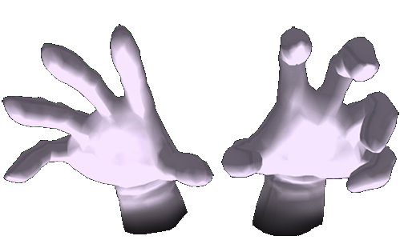
HANDS…

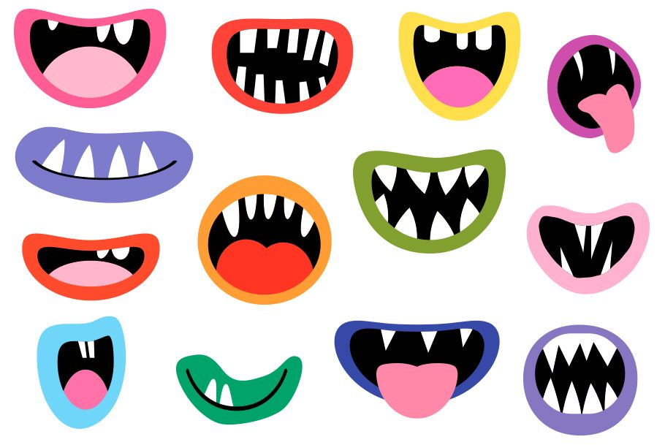
HMOUTHS…

LEGS…

