Cyber Nasties

Description

*Ensure to explore all the monsters before this activity.

Ask students to recall the names of all the monsters and describe them.

Ask students to complete the matching game attached below. Students must guess which monster the internet issues relate to.

Students must also discuss ‘How to defeat the monster’.

Discussion:

- How will the students defeat the monsters?

Learning will cover:

- Things that happen on the internet and the various ways to deal with them
- Understanding of internet issues

Resources:

Attached worksheet, pens

Cyber Nasties
Matching me up to my monster!

Call me the biggest troll but I do not like the internet being a happy place! I make sure people join in my nastiness so myself and other monsters can get stronger! Ha-ha you can’t defeat us! | 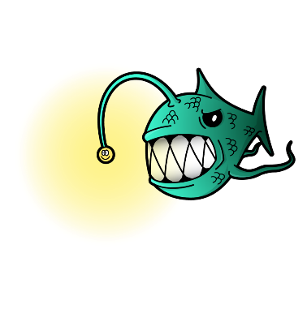
You do not know me and I can show you my nice side to become your ‘internet best friend’. Once you trust me I can show my not-so friendly side. | 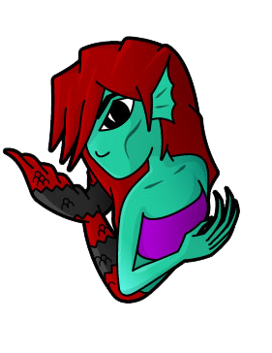
Yesterday, my ‘swirlies’ were treated to Billy Skittles for a starter, Waterside Primary school for a main course and joined Ella for dessert at Sprinkles thanks to her current location on Instagram. Because I am so generous, I shared a selfie showing Tom’s house number 6 with Selphire. | 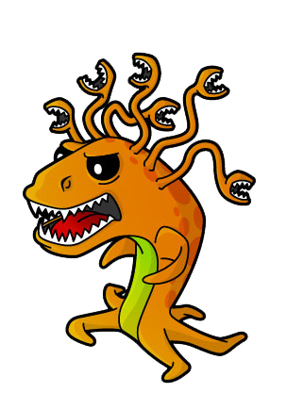
Trick or treat! Whilst you play Minecraft or Roblox, I will pop up and shine my light onto a pop-up box. This pop-up box contains a fancy link which will lead you away from your game. | 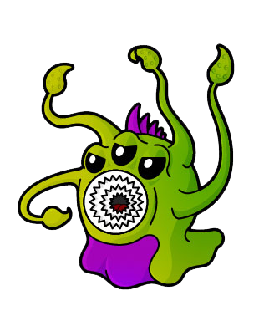
Rather cheeky, but my favourite thing in the world is pictures! Particularly those you wouldn’t want your granny to see, and not only because you lose control over them. You can’t take them back! | 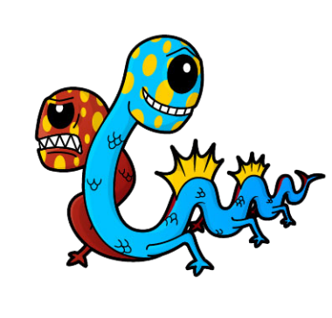

Answers

Trick or treat! Whilst you play Minecraft or Roblox, I will pop up and shine my light onto a pop-up box. This pop-up box contains a fancy link which will lead you away from your game.
Rather cheeky, but my favourite thing in the world is pictures! Particularly those you wouldn’t want your granny to see, and not only because you lose control over them. You can’t take them back!
Call me the biggest troll but I do not like the internet being a happy place! I make sure people join in my nastiness so myself and other monsters can get stronger! Ha-ha you can’t defeat us!
Yesterday, my ‘swirlies’ were treated to Billy Skittles for a starter, Waterside Primary school for a main course and joined Ella for dessert at Sprinkles thanks to her current location on Instagram. Because I am so generous, I shared a selfie showing Tom’s house number 6 with Selphire.
You do not know me and I can show you my nice side to become your ‘internet best friend’. Once you trust me I can show my not-so friendly side.

