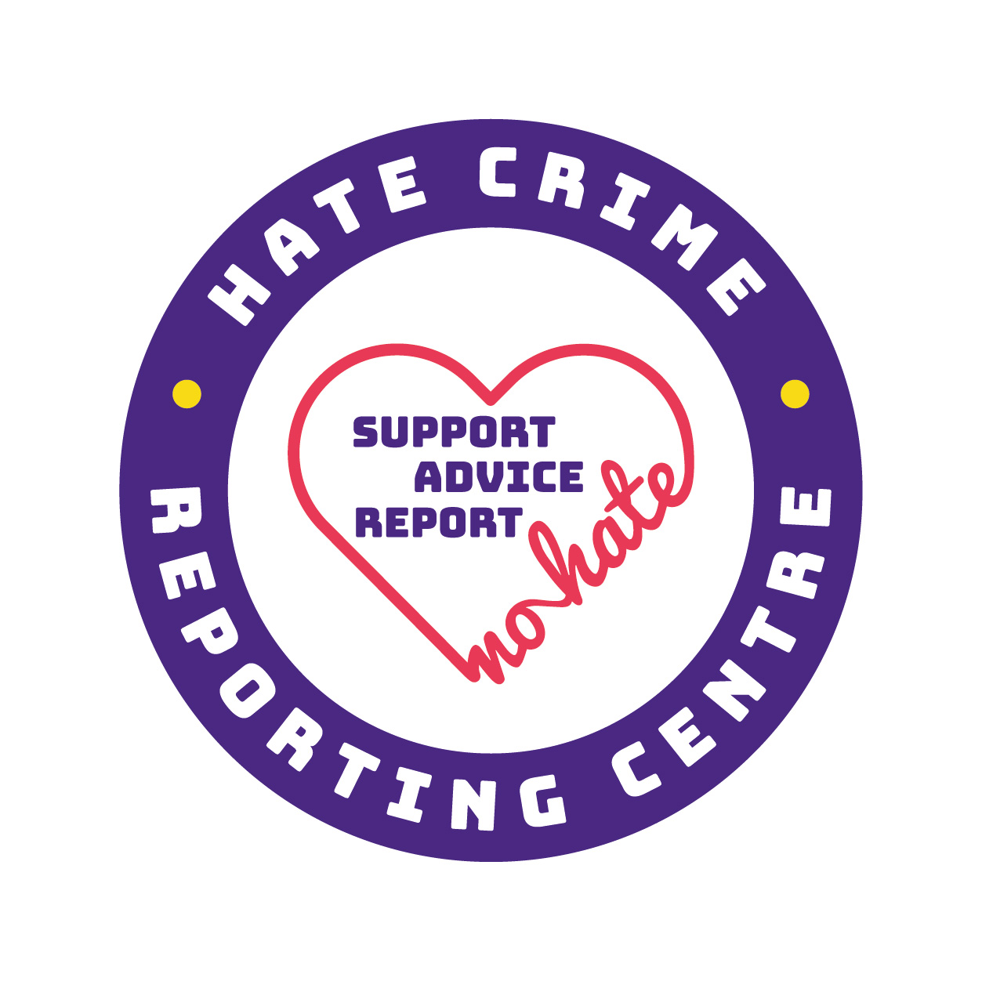
Third Party Reporting Centre Agreement

XXXX
&
Hampshire Constabulary
Principles and Commitments
Collectively, we all have a responsibility to tackle hate crime. By becoming a Third Party Reporting Centre, this organisation is demonstrating a commitment to help and support vulnerable people and those who may experience barriers that prevent them from making reports themselves to the police.
This organisation, in acting as a Third Party Reporting Centre, gives a commitment to:
- Listen to the victim
- Respect the victim's individuality
- Support the victim in reporting or recording a hate crime through True Vision
- To signpost the victim onto relevant support services

As part of the agreement, this organisation undertakes to (subject to the resources and capacity of the organisation):

- Work in partnership to support victims of hate crime and incidents. This will be coordinated via a designated single point of contact within both organisations.
- Record all incidents of hostility/hate that are brought to our attention through True Vision. Where a victim would prefer not to be named, an anonymous report will be made. Where the victim does not want police involvement, a report will be made with the relevant section reflecting this wish.
- Take immediate action where there is concern for a victim’s safety or wellbeing: this may mean, but is not limited to, urgent safeguarding or calling the police instead of using True Vision.
- Identify and signpost victims to appropriate agencies to support them according to their needs and wishes, such as the Victim Care Service.
- Discuss the need for a contact plan or any further support requirements with the victim.
- Act as a point of contact for victims if they prefer to communicate with the police via the centre.
- Communicate regularly with Hampshire Constabulary and any relevant agencies.
- Maintain the knowledge and promote awareness of the Third Party Reporting scheme.
- Help change perceptions, remove barriers to reporting and give victims and communities the confidence to report any act of hostility.
As part of the agreement, Hampshire Constabulary undertakes to:

- Work in partnership to support victims of hate crime and incidents, tailoring services to meet individual needs. This will be coordinated via a designated single point of contact within both organisations.
- Take immediate action where there is concern for a victim’s safety or wellbeing.
- Investigate all reports of hate crime as a priority in accordance with national guidelines.
- Identify and signpost victims to the most appropriate agency to support them, such as the Victim Care Service.
- Communicate regularly with the Third Party Reporting Centre and maintain a strong working relationship.
- Support the Third Party Reporting Centre and provide promotional material.
- Maintain knowledge about and promote awareness of the Third Party Reporting scheme.
- Change perceptions, remove barriers to reporting and give victims and communities the confidence to report any act of hostility.
In order to accurately understand the levels of under-reporting of hate crime and incidents, we would recommend all Third Party Reporting Centres keep an anonymized record of any hostility or hate crime they become aware of.
This information should be shared with your local police contact on a monthly basis. The information which should be recorded should include, as a minimum, the following:
- The number of victims spoken to in relation to hate crime / intolerance
- A breakdown of victims spoken to by targeted characteristic (protected characteristics and any other relevant targeted characteristics)
- The number of victims supported / referred to make a True Vision report
- A breakdown of how victims came into contact with the Centre (e.g. regular client, online search, referral through an acquaintance etc.)
- Any other relevant information

It is also recommended that Centres record details of the individual incidents in an anonymized format, including:
- What happened
- The particular protected characteristic that was targeted
- Where and when it happened
- What support the victim wanted and the preferred outcome

If the victim does not want police action to be taken, reports are still useful to build an intelligence picture in a particular area and inform policy and guidance.
Please sign below to accept these principles on behalf of your organisation.

----------------------------------------------------------
Organisation representative

----------------------------------------------------------
Hampshire Constabulary

Date:

Resources:
- True Vision Website (owned by the National Police Chief's Council): http://www.report-it.org.uk/home. This website contains useful information and is where hate crime should be reported.
- Hampshire Constabulary/OPCC Guidance and information on Hate Crime: https://www.hampshire-pcc.gov.uk/get-involved/taking-action/hatecrime.
- National Hate Crimes Reporting Procedures for Third Party Reporting Centres: http://www.report-it.org.uk/files/third_party_reporting_flowchart_1.pdf.
- A full list of all Third Party Reporting Centres operating in Hampshire and the Isle of Wight can be accessed at the following link: https://www.hampshire-pcc.gov.uk/get-involved/taking-action/hatecrime/third-party-reporting-centres. This can be used to facilitate the sharing of knowledge and best practice.
- A list of victim support organizations can be found through the following link: http://report-it.org.uk/organisations_that_can_help.

